Ag2Nut Call Minutes, November 18, 2014

Agricultur​e-Nutritio​n at the Grand Challenges Meeting 2014

Webinar
11:00 a.m., Eastern Standard Time (New York, GMT- 05:00)
Recording available at: https://jsi.webex.com/jsi/lsr.php?RCID=0916813dc43e4550960367d537cdbd32

USAID’s SPRING hosted a call on November18 on the first-ever agriculture-nutrition track at the Grand Challenges Annual Meeting 2014, held last month in Seattle by the Gates Foundation.

Laura Birx (Bill & Melinda Gates Foundation), Josette Lewis and Edye Kuyper (both of the UC Davis World Food Center) were involved in organizing the event, and presented on this call.

The track was comprised of four sessions: Diets, Markets, Convenience, and Demand. Session overviews and presentations are available at the World Food Center website: http://worldfoodcenter.org/gates_grandchallenges.html . Key findings and their implications for future activities were shared on the call, along with an overview of the (relatively) new UC Davis World Food Center.

Many thanks to the three presenters, USAID’s SPRING project (John Nicholson) for hosting the call, Anna Herforth (independent consultant) for moderating, and Anna-Lisa Noack (FAO) for taking minutes.

UC Davis World Food Center

Josette Lewis
The UC Davis World Food Center was founded one year ago and is still in its formative stages. The Center actively collaborates with a number of organizations to leverage interdisciplinary expertise to create practical solutions for sustainable food and health globally. The scope spans from local to global, focusing on adding value to research that is already ongoing at UC Davis.

To approach this vision, the Center serves as a convener of leaders that can bring intellectual capital from industry, science, non-profit sector, governments etc. to address complex challenges. We also focus on ensuring impact by connecting research with society and the market-place. And operationally, we serve as a focal point for deepening University collaboration with a number of partners to leverage interdisciplinary expertise.

Edye Kuyper
The programmatic portfolio is still developing; currently, the Center is working on some broad baskets of issues including:
- Building healthier outcomes of our food system
- Working with the Brookings Institute on the cost of obesity in U.S.
- Exploring additional opportunities to leverage the unique role CA has in the national food system as the largest producer of fruits and veg – to engage in a national dialogue about food policy in conjunction with our ag policy.
- Searching for practical solutions for ag producers and industry and policy-makers to ensure sustainability. For example, we have several activities to leverage expertise developed in our State working in a water-scarce area, struggling with droughts and also long-term trade-offs between water use and the environment.
- Contributing to the dialogue to help the public understand food and agriculture issues, not just about science but also the underlying cultural issues and how people engage with their own food system.
- Translating research into innovations that move through to the market place- commercial or non-commercial. Moving science beyond research to product development and innovation. To stimulate entrepreneurship, train researchers to be entrepreneurs, and to work closer with established industries to close gap of research and industry.
Today will focus on the first point: building healthier outcomes for our food system with a focus on low-income developing countries.

We created a diagram to visualize how we imagine UC Davis engaging with these issues. This is not comprehensive of agriculture-nutrition linkages but what our expertise at the Center can focus on.

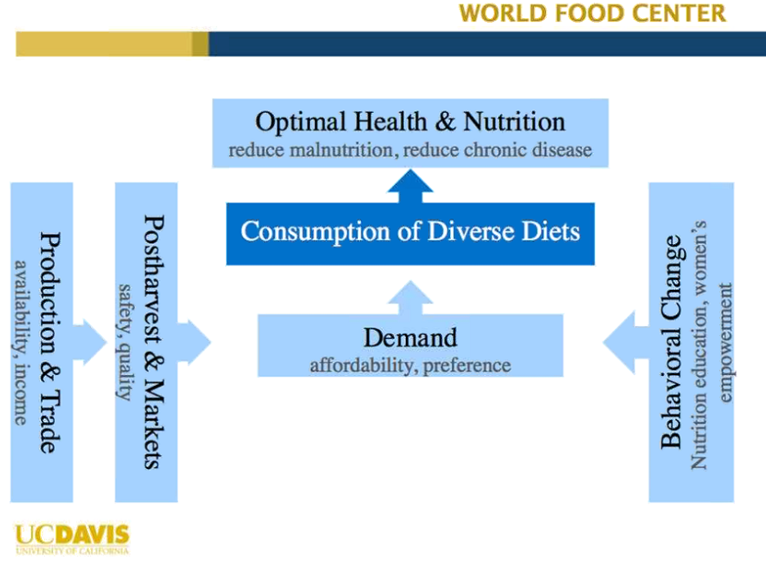
Demand is deliberately placed at the center of this diagram. Nutritionists see agriculture as a means of providing a healthy diet but if you sit on the agriculture side, you see it as a market-driven activity to generate income first and foremost. The question is, how do we create demand for a healthy diet on the nutrition side and in so doing, drive agriculture to provide the constituents of a healthy diet? We are interested in looking at undernutrition and NCDs as related to food systems. This shifts thinking beyond micronutrients and household production, and looks at systemic approaches that could potentially get us to the scale of impact we would need to achieve; shifted us quickly to looking at the marketplace. What do we know or not know about drivers of food choice in developing countries, and how do we think about influencing it?

Agriculture-nutrition track at Grand Challenges Meeting
Background on the content and presentations are available on the World Food Center website.

Edye Kuyper
I will describe a bit the outcomes of the meeting held from 6-8 October that gathered more than 1,000 people. This was the first time that the annual Grand Challenges meeting included an agriculture-nutrition track among 6 parallel tracks, which was attended by roughly 50 people per session. The goal was to expand the conversation beyond household production to look at how demographic changes affect consumption habits and households’ ability to access diverse and healthy diets.

Session overview:
- Diets: their role in linking agriculture and nutrition, their composition, and the need for improved data
- Markets: their impact on the links between agriculture and nutrition
- Convenience: time, resource constraints and their implications for food choice
- Demand: opportunities for agriculture and nutrition sectors to increase the market pull for healthy foods.

Key Findings:
- Related to availability
  - Diets are where agriculture and nutrition meet, and demand mediates agriculture’s contribution to diet quality. Without demand, there will not be sufficient supply
  - Food supply is inadequate for a healthy diet in some countries. Presented findings from a Dietary Gap Assessment in Cameroon led by Kay Dewey and Mary Arimond at UC Davis. It looked at diets using the information from DASH diet recommendation to identify nutritional gaps (DASH is perhaps too Western and may need to be catered to the specific context but given time-constraints and that it’s not backed by a government, used this).
  - Interventions that reduce risk to producer households smooth demand
- Food choice
  - Consumer demand mediates agriculture’s connection to dietary quality
  - Caregivers are willing to “trade up” to buy special (healthy) foods for their children, but health is a lesser factor in choice of adult foods
  - Increasing market integration influences diets, even among the poor (but dietary changes are not necessarily more healthy)
  - Regional differences influence consumption more than age or sex
  - Nutrition-related social and behavior communication change efforts have not adequately impacted food choice

Laura Birx
Typically the Grand Challenges meeting is a bit smaller, but as it was the 10th anniversary, it was hosted in Seattle and was much bigger. Two nutrition-related challenges were launched at this event.
- The first was called ‘Creating and Measuring Integrated Solutions for Healthy Birth, Growth and Development’ (http://gcgh.grandchallenges.org/GCGHDocs/ACT_RFP.pdf ).
- The second was called “Putting Women and Girls at the Center of Development’ (http://gcgh.grandchallenges.org/GCGHDocs/WGCD_RFP.pdf) and was launched by Melinda Gates. This calls for more action and sees women’s empowerment as a goal in its own right rather than a means to achieving improved child nutrition or other health outcomes. It is looking for new ways to decreasing the gender gap by scaling up approaches that are known to work and also to develop better measures to evaluate their impact. This is very new to us.

Discussion

(Q) Anna Herforth
What was it that you were aiming to get from the agriculture-nutrition track at the Grand Challenges meeting?

(A)Laura Birx
Leadership came to me in late spring requesting such a track. There is a lot of work going on and a desire to consolidate this knowledge and get it streamlined. For many of us on the phone – this is 100% of our day and so it may seem redundant. It turned out to be of real added value to agriculture colleagues whose day-job does not include nutrition. A huge success was working with the World Food Center- bringing in new participants. This created a diversity of presentations. Many of us in the international development world have very little idea of what is going on domestically. This brought in new approaches, which is exactly what the Grand Challenges is about.

Bill and Melinda Gates Foundation is currently revising its nutrition strategy. The partnership between agriculture and nutrition team has been growing so as this continues, it may also be incorporated into this strategy.

(A)Edye Kuyper
This was an area we were looking to explore at the World Food Center even before collaborating with Bill and Melinda Gates Foundation. We were looking to go beyond micro-nutrients and household level food production indicators to look at more systemic issues. This helped us shift our focus to look at the growing importance of the market place, food systems for the poor, and to question drivers of food choices in developing countries. We also started thinking about what strategies can affect food choices even when healthy diets are available, how people are making choices when incomes rise and availability changes. We wanted to look at how food systems could deliver healthier outcomes.

(Q) Emily Ruppert: The issue of demand is a wonderful concept to work with as we evolve in this discussion on agriculture and nutrition. So much of the discussion has been on production- what kind of intervention will produce highly nutritious crops. I like that we also need to look at the social aspect here. Both in the Grand Challenges, UC Davis or other organization, are you looking at the socio-economic side of the nutrition conundrum? I see this as a key connection. Is there going to be funding available through different organizations to do this kind of research?

(A) Edye Kuyper
We are not specifically engaged in research on the topic at UC Davis, though it is an area of extreme personal interested. I see it as an opportunity to link agriculture with nutrition areas. The WFC would like to continue engaging in this conversation.

(A) Josette Lewis
To add to the socio/ethnographic approach, we had several talks at the track in Seattle looking at issues of convenience food discussing what are some of the factors that influence decisions, what happens when there are risks involved? We also looked at economic trend data in developing countries that shows that people are willing to cut back on food expenditures rather than decrease their asset base. Questions to be further considered include when incomes rise, how do people allocate these funds and which food products do they purchase? Some of this trend data gives us a sense of the outcomes but does not explain what lies behind the choices people are making. We haven’t explored as much as we need to.

(A)Laura Birx
Regarding social marketing and funding opportunities, Gates and DfID issued an RFA in the summer called ‘Drivers of Food Choice’ that directly addresses some of these questions. We are coming to the end of the competitive process. The idea is to work with a partner to issue a call for qualitative research on food choices in Africa or Southeast Asia. We hope this will come out next year. This will become a larger area of interest that will continue to grow.

We are also partnering with the University of Pennsylvania’s Annenburg School for Communication looking at the potential for behavior change communication (BCC) in India, Nigeria and Ethiopia. Danielle Naugle from UPenn (on the call) is among these. There are many experts on generating demand so we need to capitalize on that in these countries.

(A &Q) Anna Herforth:
At the link for the GC meeting, you might want to check out Marti van Liere’s presentation (slide 12 on), where she compares public health BCC and private sector marketing, which illustrates what the public sector can learn from private sector...

I also have a comment on the framework: Interesting that you included “affordability” in the demand box; price is a function of both supply and demand. What were the conversations about that as you developed the framework?

Josette Lewis
Demand is in the center, but to the left of the diagram are actions to increase supply and improving productivity of fruits and vegetables. How you create demand, social marketing, BCC has been underexplored in developing countries. There is still a basic problem of availability and affordability of basic staple foods. Studies have shown that increasing productivity of staples decreases the price and therefore accessibility and consumption. The question is whether this is the same for increasing the production of vegetables and fruits and animal-sourced foods. Affordability is largely a function of agricultural production in addition to how you create demand for healthy foods.

(Comment) Beth Mitcham (Director of Horticulture Innovation Lab)
In the US, the price of produce in the supermarket is really not high compared to availability in production. It’s really just based on the price people are willing to pay in the supermarket. Need to be clear that this dynamic exists. Not so clear in developing countries- but as supermarkets become more important, it is likely that these dynamics will also emerge. It is a bit more complex and requires further study.

Participants (41 joined the call):

Name | Job title | Company name
Aaron Buchsbaum | Social Media and Community Manager | Secure Nutrition
Abubacker Siddick | Researcher | M.S.Swaminathan research foundation
Andrew Jones | Assistant Professor | University of Michigan
Anna Herforth | Independent Consultant
Anna-Lisa Noack | Consultant, Nut in Ag investments
Anne Williams | Grad Student | UC Davis
Beth Mitcham | Director | Horticulture Innovation Lab, UC Davis
Charlotte Block | Technical Director of Nutrition | ACDI-VOCA
Danielle Naugle | Research Director | Annenberg School for Communication
Edye Kuyper | Lead Nutrition Analyst | World Food Center, UC Davis
Emily Levitt Ruppert
Josette Lewis |  | World Food Center, UC Davis
Goulda Downer
Ibironke Olofin | Post-Doctoral Research Fellow | Harvard School of Public Health
Jen Burns
John Nicholson | Knowledge Management Manager | SPRING
Karen Siegel | PhD student | Emory
Kathleen Kurz
Kathy Wiemer | Senior Fellow | General Mills
Kim Andrup | Major Donor Relations Officer | Freedom from Hunger
Kristi Tabaj |  | TOPS
Laura Birx |  | BMGF
Lidan Du |  | SPRING
Lora Iannotti | Assistant Professor | Washington University in St. Louis
Mary Arimond
Mandy Willig | Assistant Professor | University of Alabama at Birmingham
Rodney Carew | Project Leader | Open Capital Advisors
Sarah Brunnig
Sithembile Mwamakamba | Programme Manager | Food, Agriculture and Natural Resources Policy Analysis Network
Tara Acharya | Senior Director | PepsiCo
Victor Pinga |  | SPRING
Yunhee Kang | PhD Student | Johns Hopkins School of Public Health
9 Call-in Users

