Developing a Seasonal Calendar
Session Guide Five of the Nutrition-Sensitive Agriculture Training Resource Package
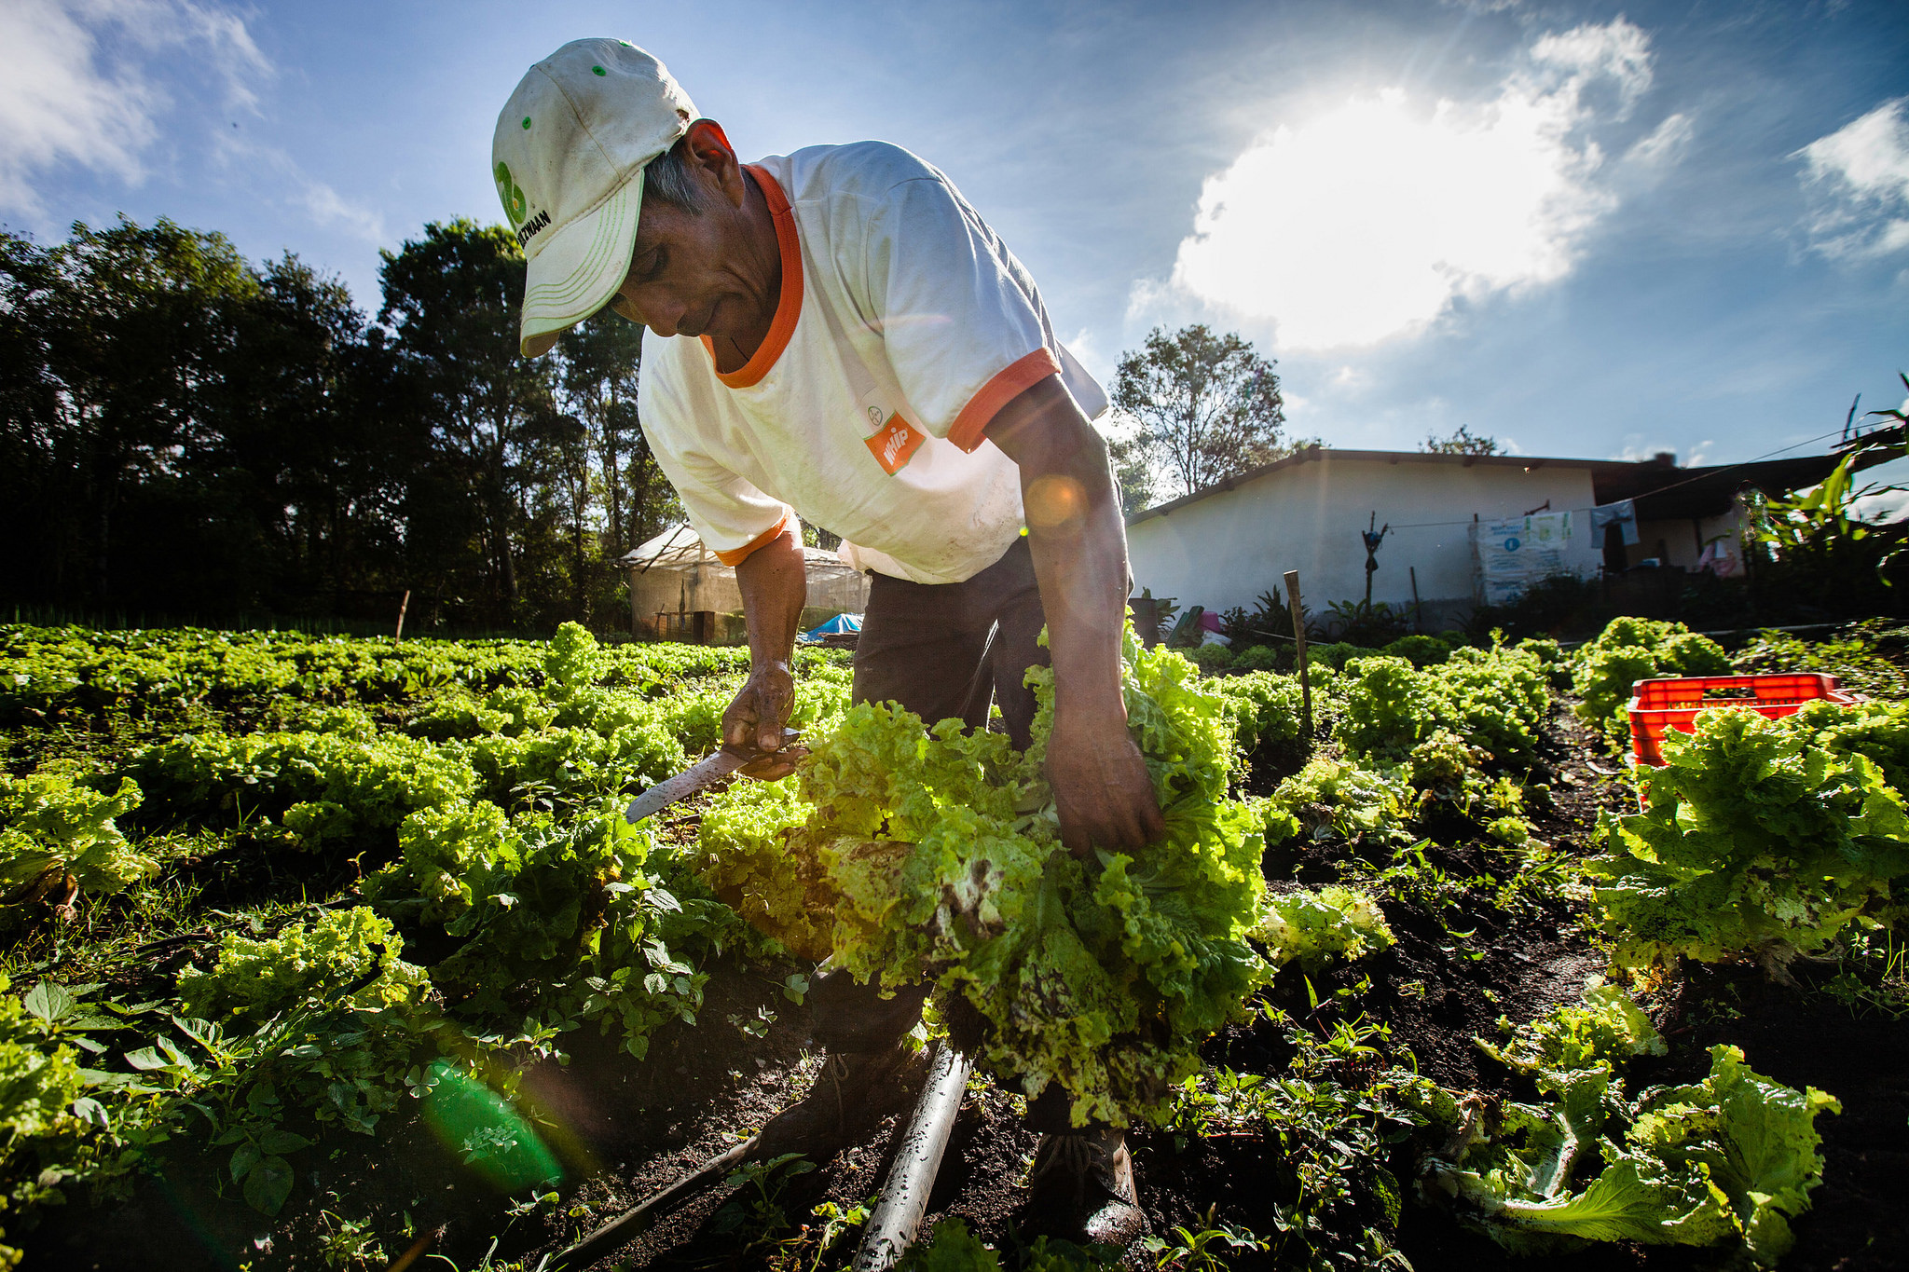

Developing a Seasonal Calendar
Session Guide Five of the Nutrition-Sensitive Agriculture Training Resource Package

ABOUT SPRING
The Strengthening Partnerships, Results, and Innovations in Nutrition Globally (SPRING) project is a seven-year USAID-funded cooperative agreement to strengthen global and country efforts to scale up high-impact nutrition practices and policies and improve maternal and child nutrition outcomes. The project is managed by JSI Research & Training Institute, Inc., with partners Helen Keller International, The Manoff Group, Save the Children, and the International Food Policy Research Institute.
RECOMMENDED CITATION
SPRING. 2018. Developing a Seasonal Calendar: Session Guide Five of the Nutrition-Sensitive Agriculture Training Resource Package. Arlington, VA: Strengthening Partnerships, Results, and Innovations in Nutrition Globally (SPRING) project.
DISCLAIMER
This report is made possible by the generous support of the American people through the United States Agency for International Development (USAID) and Feed the Future, the U.S. Government’s global hunger and food security initiative, under the terms of the Cooperative Agreement AID-OAA-A-11-00031 (SPRING), managed by JSI Research & Training Institute, Inc. (JSI). The contents are the responsibility of JSI and the authors, and do not necessarily reflect the views of USAID or the U.S. Government.

SPRING
JSI Research & Training Institute, Inc.
1616 Fort Myer Drive, 16th Floor
Arlington, VA 22209 USA
Phone: 703-528-7474
Fax: 703-528-7480
Email: info@spring-nutrition.org
Internet: www.spring-nutrition.org

COVER PHOTO: Lettuce Harvesting in Intibuca. USAID-ACCESO/Fintrac Inc.

Contents
Preparing to Present This Session 1
Purpose 1
Objectives 1
Estimated Duration 1
Materials 1
Core Content 2
Exercise: Examining the Effect of Agricultural Activities on Nutrition in the Local Context 2
Additional Resources 9

Preparing to Present This Session
Purpose
This is Session Five of seven that are included in the Nutrition-Sensitive Agriculture Training Resource Package.
Building a seasonal calendar helps participants explore and understand how seasonal changes in agriculture and livelihood tasks, cash flow, labor requirements, as well as the health environment, affect farmers’ access to food, health, and care. This exercise-based session is a good starting point for participants to explore several concepts around agriculture, income, labor, and nutrition related to the pathways.
Before starting the session, the facilitator should have an idea of how seasonal changes impact agriculture and nutrition in the context. This knowledge will allow the facilitator to guide participants through the exercise and discussion.
Objectives
By the end of this session, participants should be able to—
- describe the agricultural context and how it varies throughout the year in areas where their activity functions
- articulate how agricultural constraints (growing season, holidays, seasonal illnesses, changes in weather) affect the wellbeing of communities
- identify opportunities to make agricultural activities more nutrition-sensitive.
Estimated Duration
1 to 1.5 hours
Materials
- There are no slides to accompany this session.
- Masking tape or other method for fixing flipchart pages to the wall
Core Content
Facilitator Note: This Seasonal Calendar session can be adapted to illustrate several concepts related to nutrition and agriculture. Before starting the exercise, take some time to focus on your specific purpose and adapt the introduction and discussion to fit your context and relevant aspects of this context you would like for participants to explore. For example, you may want to refine the seasonal calendar to emphasize specific aspects of the environment in which you are working. You could choose these aspects of the environment based on what most affects community members’ access to food, health, and care. If relevant, you could also choose these aspects of the environment based on your expected activities. As you create the template seasonal calendar, you can determine how deeply you would like participants to explore seasonal activities within a given context.
Over the years, SPRING has created various versions of the seasonal calendar to emphasize seasonal trends, such as agricultural production tasks, cash flows, and illnesses. Sometimes SPRING has included all topics, and other times we have only included one or two topics. While planning this session, it is important to determine which aspects of the context are most important to explore. Furthermore, while planning, think through the process to remove some of the discussion questions, create questions with a narrower scope, or refocus parts of the exercise, depending on what you would like participants to take away.
This exercise can be adapted for non-literate participants by using icons, rather than words, to represent different seasonal elements.
Exercise: Examining the Effect of Agricultural Activities on Nutrition in the Local Context
About this Exercise
- Goal: to increase understanding of the context in which we work by analyzing the current local growing seasons and agricultural activities.
- Duration: 60–90 minutes
- Materials: None
- Preparation: Determine how many seasonal calendars your training group will need to use during this exercise. It is best if each group (one for each seasonal calendar) has four to five participants. You will need to have sufficient materials for each group.
Determine whether you would like to focus your seasonal calendars on agricultural activities associated with specific crops. If you would like to focus on agricultural activities for specific crops, use Option A in this exercise. If you would only like to focus on overall labor, use Option B in this exercise.
If choosing Option A, you must determine the crops/animals on which you would like to focus. When thinking through which crops/animals, select a range of key crops grown and livestock raised in the target area. Selecting a mix of staple food crops and several nutrient-rich crops and livestock is best. Choose the crops/animals most popularly grown/raised in your target agro-ecological zone(s). For example, in Guinea, we selected rice, maize, cassava, cowpea, sweet potato (including leaves), and vegetables (tomato, pepper, and okra). The selection of crops can also be done together with participants, depending on the time you have available. It is possible to conduct this exercise while examining multiple agro-ecological zones. If you decide to examine multiple agro-ecological zones, ensure that you create a seasonal calendar for each zone.
Build your calendar(s) on the wall (see samples below)
  - X-axis (horizontal): Write months of the year, with one blank row under it.
  - Y-axis (vertical): Inserting lines along with the categories shown in the diagram below, write the following categories:
  - Option A: Seasons, Holidays, Crop/Animal 1, Crop/Animal 2, Crop/Animal 3, Crop/Animal 4, Food sufficiency, Labor (women), Labor (men), Cash flow, Health, Environmental shocks.
  - Option B: Seasons, Holidays, Food sufficiency, Labor (women), Labor (men), Cash flow, Health, Environmental shocks.

Facilitator Note: As a facilitator, you may need to build more than one seasonal calendar, depending on your audience and its size as well as the focus of your training. These directions include two options:
Option A: Small groups each create their own seasonal calendar, representing different agro-ecological zones and specific crops. For example, SPRING worked with local partners in Guinea to create a seasonal calendar representing each zone where the partner works. We created one for Kindia, one for Mamou, and one for Faranah, as weather patterns, activities, holidays, food produced, and food consumed varied regionally.
Option B: Small groups each create a seasonal calendar which focuses on general trends, like availability of specific food types, demand for labor, and times of the year when money is typically made or spent.
Option A may be preferable for a project working across multiple agro-ecological zones, while Option B may be preferable for a project working in a single, uniform agro-ecological zone.

Sample seasonal calendars
Option A
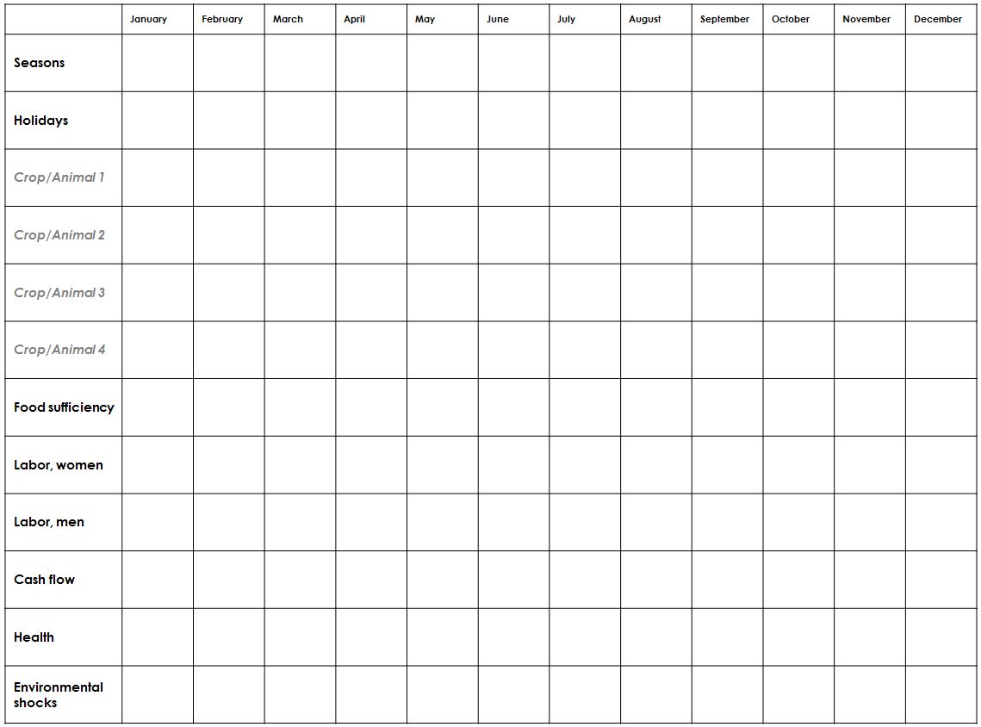

Option B
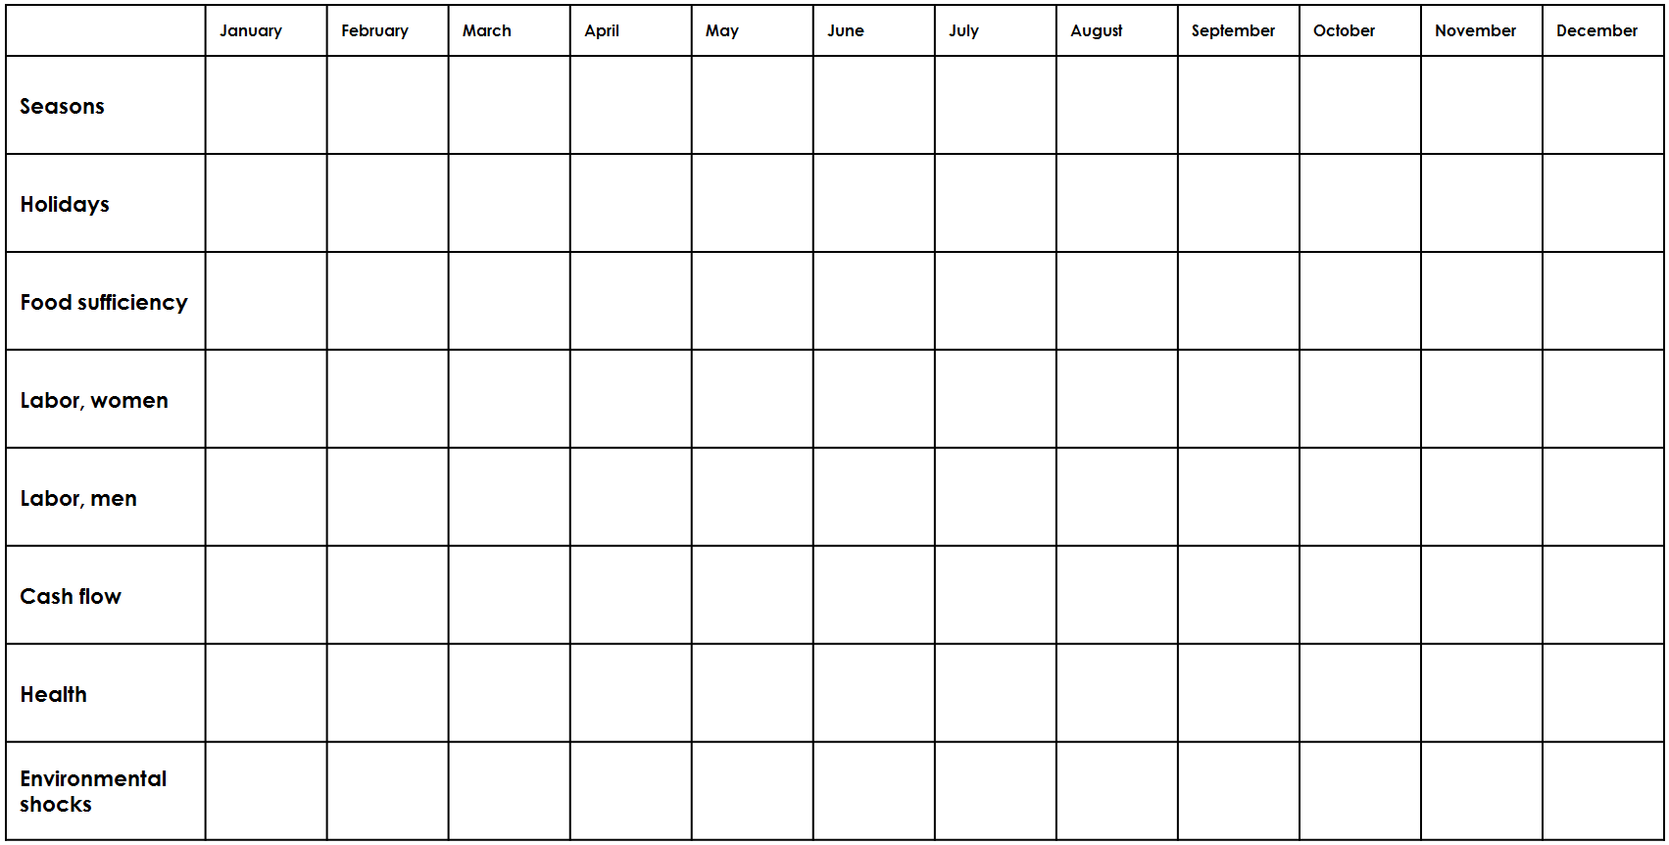

Exercise Instructions
- Throughout this workshop, we have discussed improving agricultural practices that can help to solve some of the nutritional challenges faced by communities. We live in environments that change, so these challenges are not the same throughout the year.
- Introduce the template
  - Option A – As you look at the seasonal calendar on the wall, you will see the months listed across the top. On the side, we have created rows, so that you may list several crops/livestock. We have also made rows for seasons (dry, rainy, etc.), holidays, production of crops/animals, food sufficiency, women’s labor, men’s labor, cash flow, health, and environmental shocks. You will explore each of these rows and complete the seasonal calendar during your group work.
  - Option B – As you look at the seasonal calendar on the wall, you will see the months listed across the top. On the side, we have listed general seasonal trends, including rows for seasons (dry, rainy, etc.), holidays, food sufficiency, women’s labor, men’s labor, cash flow, health, and environmental shocks. You will explore each of these rows and complete the seasonal calendar during your group work.
- Divide participants into groups of four to five. In each group, there should be at least one person who is familiar with agriculture in the area.
  - Option A – Assign each group an agro-ecological zone to work with and explain the two to four of the predominant crops and/or livestock that are produced in that zone.
  - Option B – Assign each group to fill out the seasonal calendar.
- Ask participants to start by discussing and agreeing on what seasons they use locally (e.g., dry season, rainy season, and/or cold season).
- Then, within your groups, discuss each row and list the activities that take place during each month of the year.
  - Option A only – Begin by discussing key agricultural activities for each crop and/or livestock. The groups should discuss when each of these activities takes place and then draw/write them on the calendar on the wall.
  - For example: land preparation during the months of May and June; planting in July; weeding in August; harvesting in September; drying/transformation/storage in September, October, and November; and selling in October, November, December, and January.
- Continue the discussion by mapping out which month(s) of the tasks listed in each row takes place. If you use one of the example calendars provided, discuss:
  - Seasons (wet, dry, etc.)
  - Holidays/Festivals/Celebrations
  - Option A only – Reflect the tasks completed during each month of the year for the associated crop/livestock
  - Food sufficiency – Are there times when food is very scarce?
  - Women’s labor – Reflect both agricultural and non-agricultural tasks, if possible
  - Men’s labor – Reflect both agricultural and non-agricultural tasks, if possible
  - Cash flow/Income flow – Which months is cash flow positive (i.e. earnings exceed expenses)? Which months is cash flow negative?
  - Health – What are the most common illnesses that affect families living in the target area by month (e.g., malaria, respiratory infections, diarrhea)?
  - Environmental shocks – Are there shocks that happen during the year such as floods, drought, heavy rains, heavy winds, etc.? When are they?
- This is your agricultural calendar. It may take 30–40 minutes to prepare depending on the number of people working together. Larger groups can be separated into sub-groups that split the various rows among them.

Discussion: Examining the Seasonal Calendar
- Distribute one page of flipchart paper to each group.
- In your groups, you will have 20 minutes to work. Discuss the following questions:
  - How is community members’ ability to access food, health, and care impacted by each row on the seasonal chart?
  - What are the top three challenges and top three opportunities, per season, related to accessing food, health, and care?
- After your group has finished discussing, record your findings on the flipchart.
- Invite each group to present their findings in plenary.
  - Option A: In the large group, share the most critical seasonal challenges and opportunities affecting farmers’ access to food, health, and care across the different zones. This presents an opportunity to compare unique aspects of each zone. As each group presents, encourage discussion and inquiry throughout each presentation. Sharing the rationale behind each group’s selections is an opportunity to learn.
  - Option B: In the large group, discuss each group’s rationale behind the three challenges and opportunities that they identified. As each group presents, discuss various ways that the environment and seasons affect community members’ access to food, health, and care. As a facilitator, ensure that the rationale behind each group’s work is strong and coherent.

Discuss: Now that we have identified seasonal challenges and opportunities affecting families’ access to food, health, and care: How can our project activities reduce challenges and build on opportunities to improve access to food, health, and care? [Take several responses.]

Facilitator Note: During this exercise, you may need to help participants focus on the categories listed on the left side of their calendars. Review the terms below and guide participants as needed. As guidance:
- Seasons: This is simply how people divide the year. For example, there may be two rainy seasons, a cold dry season, and a hot dry season. It is important that the full group agree on when these seasons begin and end. Because seasons have been shifting, this topic often requires some discussion to reach consensus.
- Holidays/Celebrations: What are the key holidays and celebrations and when do they occur? Once these are included on the calendar, the discussion could center around how these holidays affect demands on time, labor, income/expenditure, and food. For example, holidays may limit time available to make money (income) or provide care (health).
- Food sufficiency: This line should show when food stocks tend to be low or high for the majority of families. It is also useful to note the sources of foods most available during lean months, when for example, wild foods might be more commonly found in households or diets may be sourced through market purchases due to depleted household stores. Food sufficiency determines decisions made around food purchases. With low food sufficiency, families have few choices of how much food to eat and what kind of foods to eat.
- Labor roles: Labor roles included on the calendar may also reflect times of the year when many families have one or more members migrating to work in cities or other countries. Labor directly impacts women’s health, which is especially significant to pregnant women and women exclusively breastfeeding, and through them, children under two years of age. Limited labor limits production as well as income. On the other hand, the time that is dedicated to labor potentially takes away time from health and care.
- Cash flow: Income and expense flows can be reflected by month using one or more “+” symbols to reflect months in which total income exceeds total expenditures and one or more “-” symbols to reflect months in which expenditures exceed income. Income and expense flows determine a family’s ability to access resources, affecting the amounts, quality, and diversity of food available to it, as well as their access to health services, and WASH supplies. Discussion about income and expenses might point to strategies such as promotion of savings among women and men or promotion of household or community storage technologies/ systems that would result in increased income in months that are currently in the negative.
- Health: Health determines family members’ ability to work productively, which impacts the family’s income and their food production. Discussion related to the completed calendar may identify when cash flow might be low while illness is high and consequently, potential health expenses cannot be met. They may also identify when illness burden is high and food stores and income are low, putting even more stress on resource-poor families. Being able to identify these times of year may inform the need to develop program strategies that help mitigate greater illness and food insecurity or may point to the need for linkages to other programs, such as social safety nets.
- Environmental shocks: In addition to health shocks, environmental shocks may affect both short- and long-term food access, as well overall income, which may also have consequences for health.
The following images show two examples of a completed seasonal calendar. There are many ways to make a seasonal calendar, including showing a seasonal calendar on a PowerPoint slide. It is important to make a seasonal calendar in a format that is most easily understood by the participants, allows them to modify the calendar so that they can take ownership of it, and facilitates their interaction with the calendar as they complete the group work.
Example of Variation of Option A
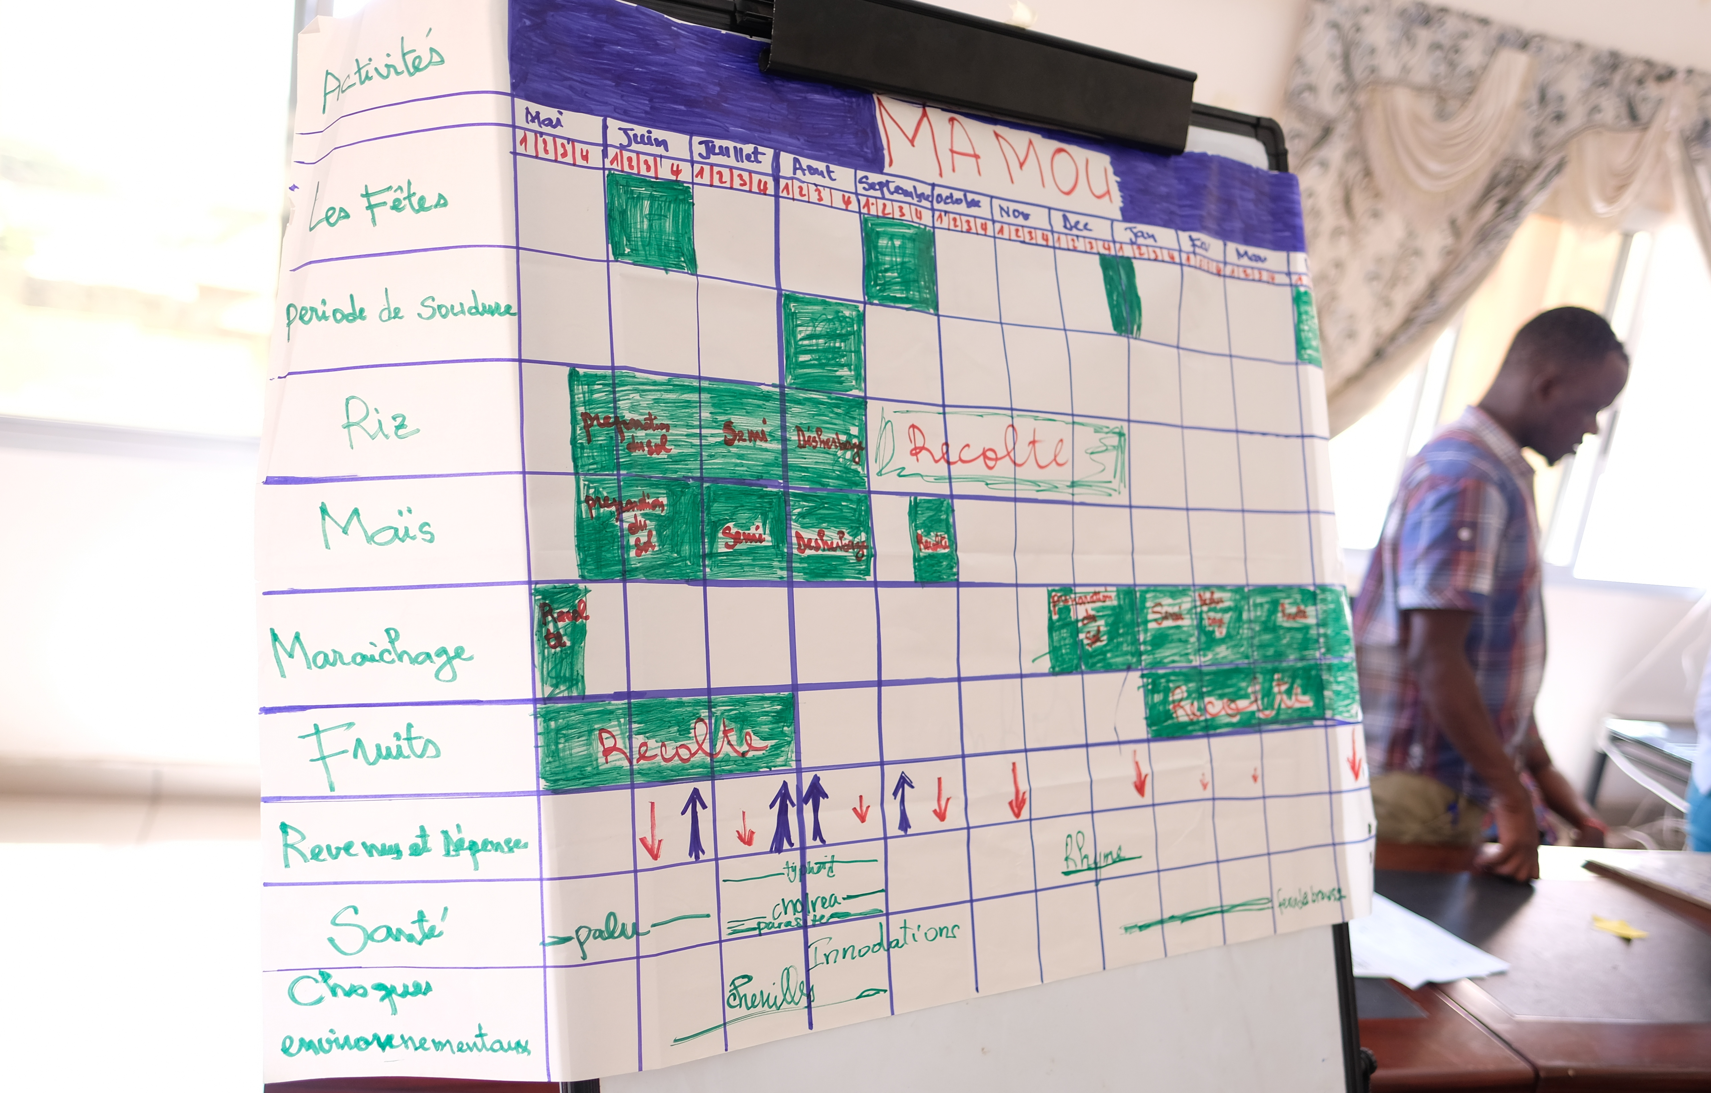

Example of Variation of Option B
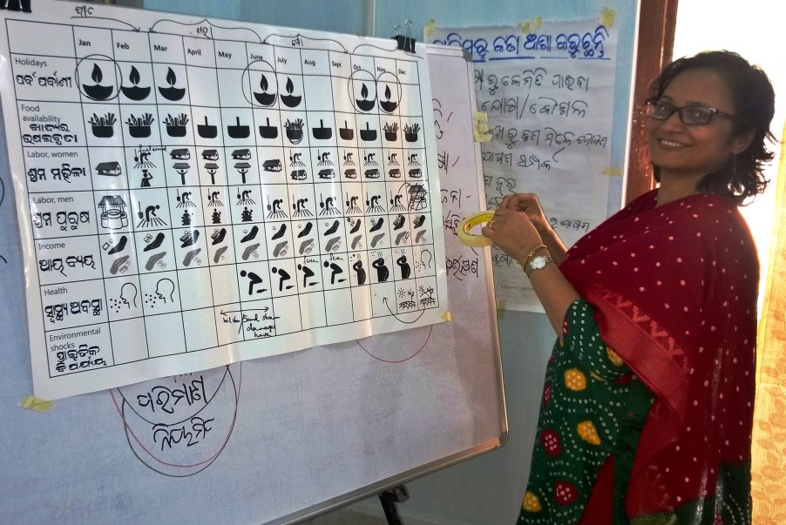

Lesson Learned: This seasonal calendar exercise provides insight into the local context for both the facilitator and the participants. A completed seasonal calendar can be referenced by the facilitator throughout other workshop sessions. The seasonal calendar can also be useful to participants as they think through their agriculture activities.
The timing of agricultural activities is important when planning behavior change interventions, group meetings, and project monitoring activities. For example, understanding times of the year when farmers earn income, or have high expenses, can help with the timing of program activities. Thinking through seasonal holidays, illness outbreaks, harsh weather, and other big events helps participants see the types of challenges and competing priorities that farming households face throughout the year.

Additional Resources
The following resources provide further information on seasonal calendars:
SPRING. 2017. Accelerating Behavior Change in Nutrition-Sensitive Agriculture. SPRING Online Training. https://www.spring-nutrition.org/publications/training-materials/accelerating-behavior-change-nutrition-sensitive-agriculture
CARE. 2014. Formative Research: A guide to support the collection and analysis of qualitative data for integrated maternal and child nutrition program planning. Atlanta, GA: CARE.

SPRING
JSI Research & Training Institute, Inc.
1616 Fort Myer Drive, 16th Floor
Arlington, VA 22209 USA
Tel: 703-528-7474
Fax: 703-528-7480
Email: info@spring-nutrition.org
Web: www.spring-nutrition.org

