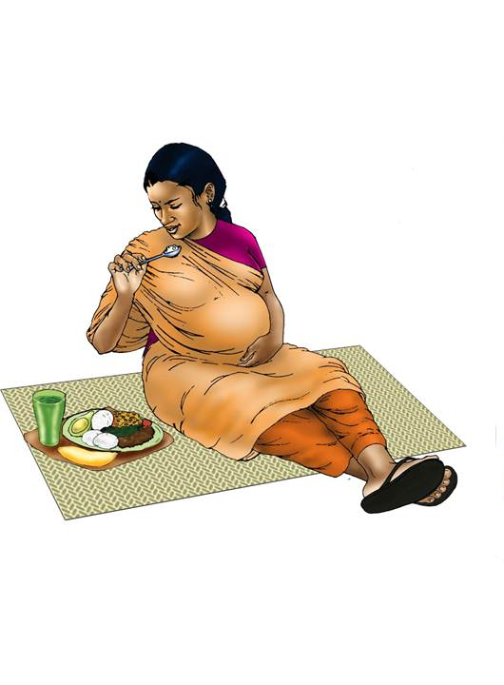

PREGNANT
0–270 DAYS

NUTRITION DURING PREGANCY

BIRTH
1 DAY
IMMEDIATE BREASTFEEDING

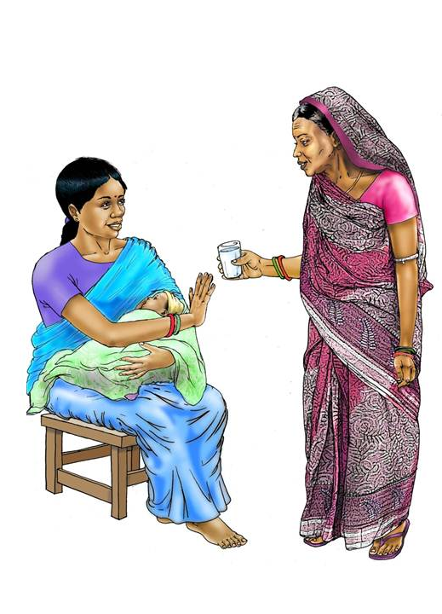

0–6 MONTHS
181 DAYS
EXCLUSIVE BREASTFEEDING

6–8 MONTHS
92 DAYS

CONTINUED BREASTFEEDING

INTRODUCTION OF COMPLEMENTARY FOODS

9–11 MONTHS
92 DAYS
CONTINUED BREASTFEEDING
INCREASED FREQUENCY OF COMPLEMENTARY FOODS

12–24 MONTHS
365 DAYS
CONTINUED BREASTFEEDING
INCREASED FREQUENCY OF COMPLEMENTARY FOODS

