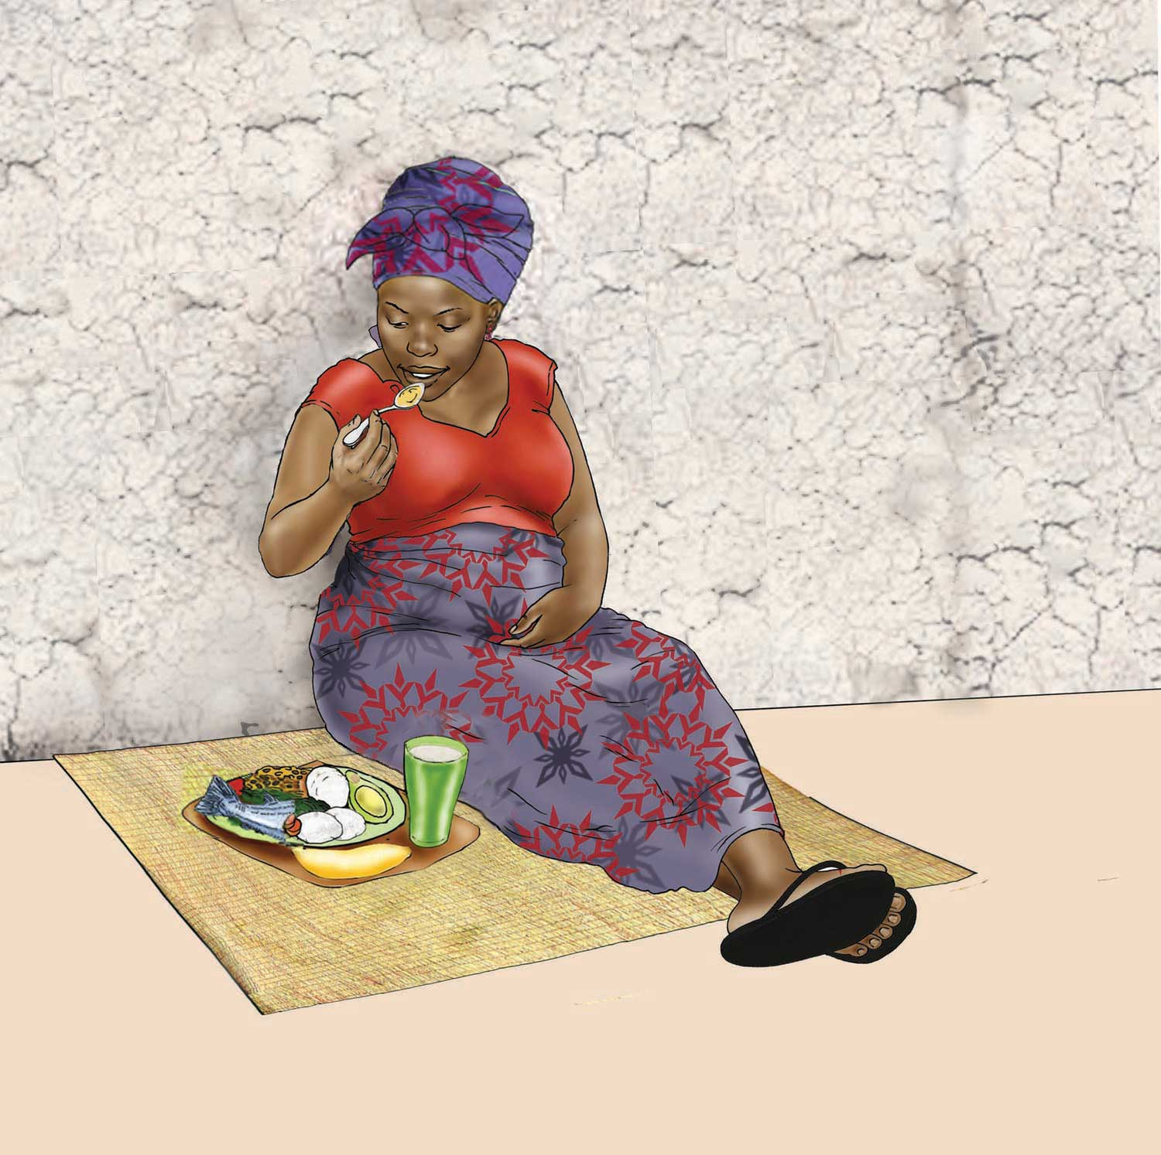

PREGNANT
0–270 DAYS

NUTRITION DURING PREGANCY

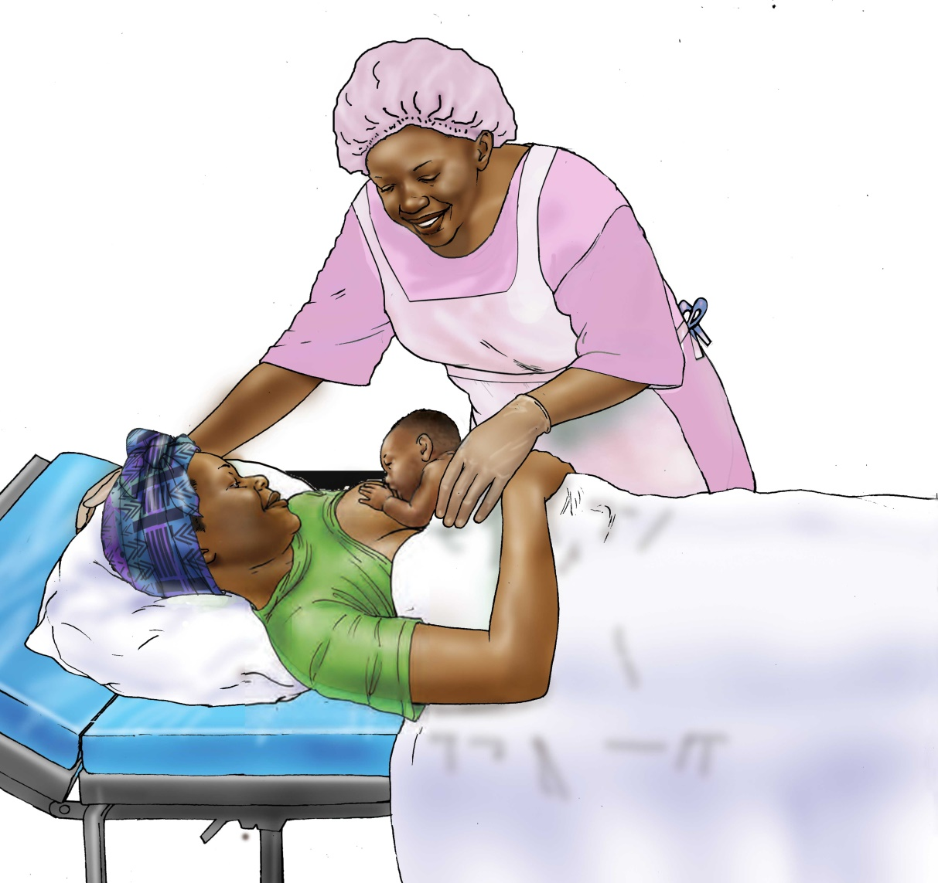

BIRTH
1 DAY

IMMEDIATE BREASTFEEDING

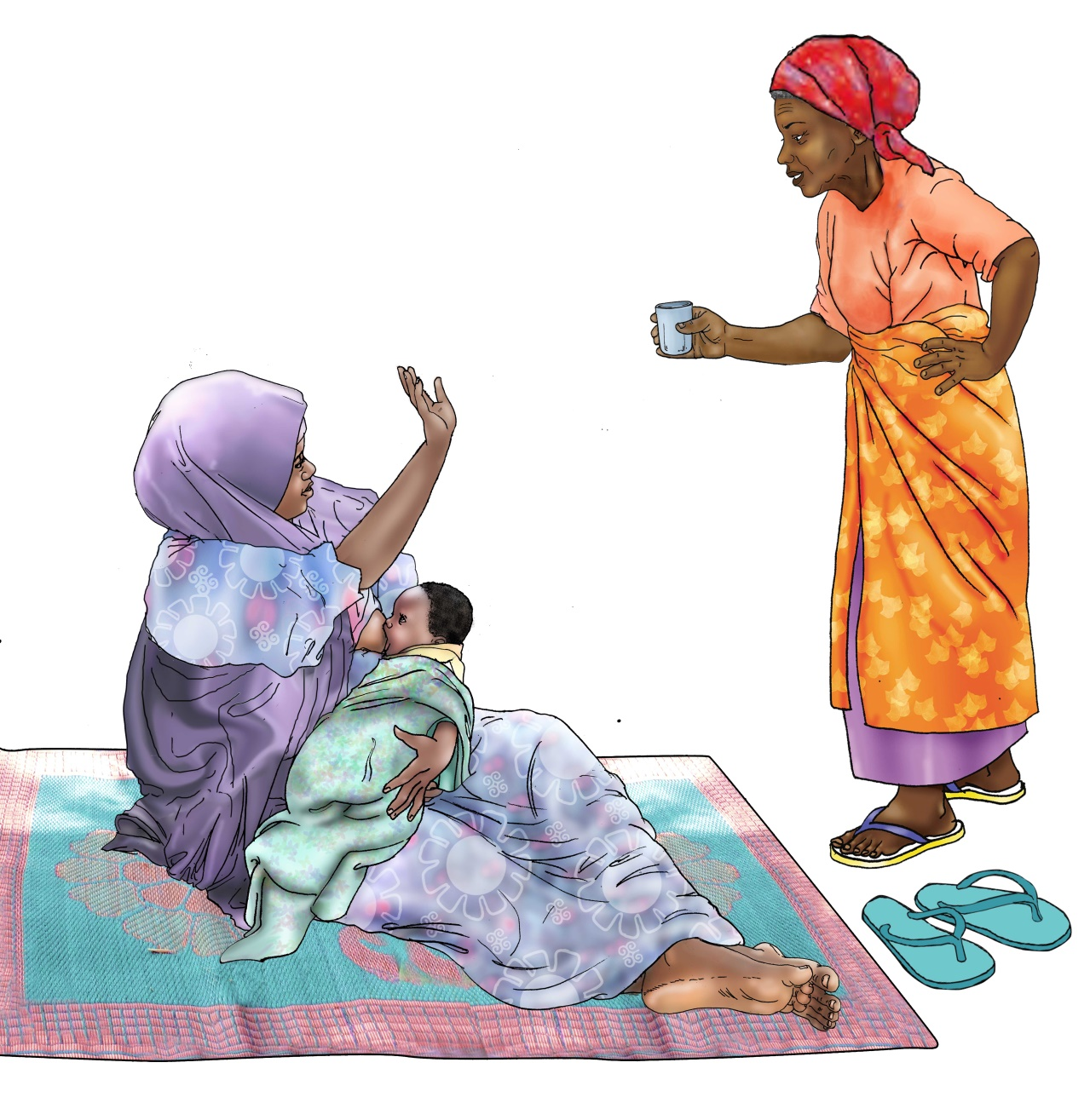

0–6 MONTHS
181 DAYS

EXCLUSIVE BREASTFEEDING

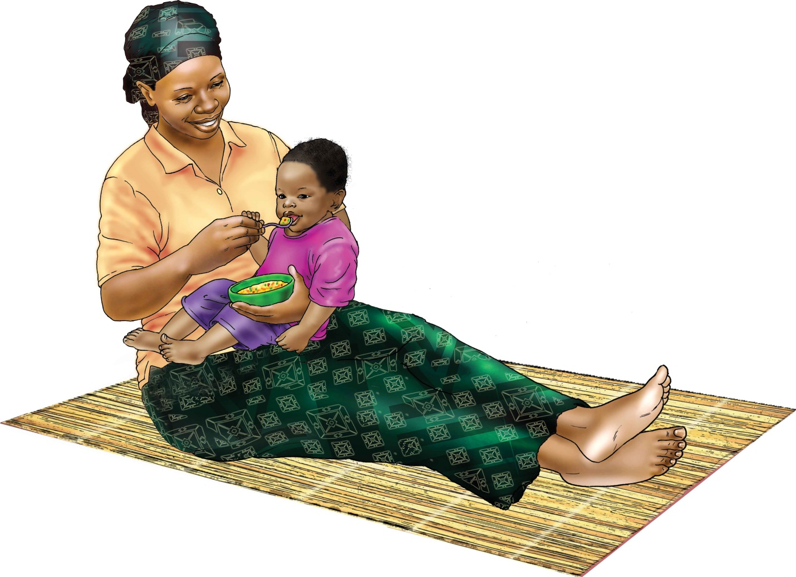

6–8 MONTHS
92 DAYS
CONTINUED BREASTFEEDING
INTRODUCTION OF COMPLEMENTARY FOODS

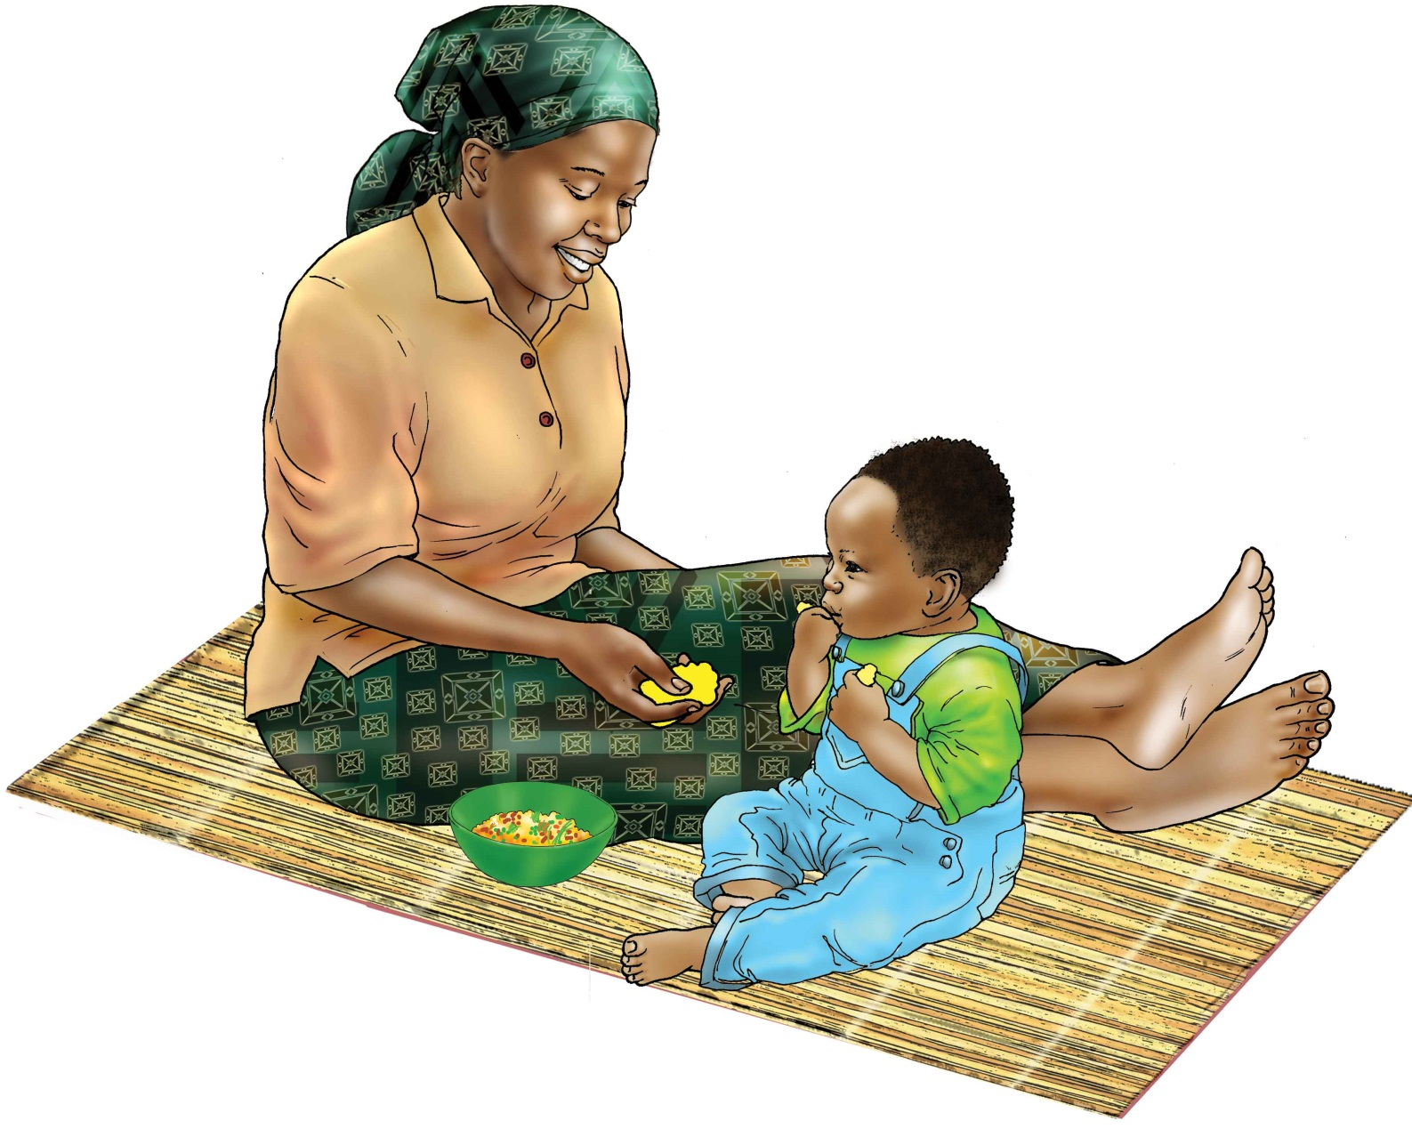

9–11 MONTHS
92 DAYS
CONTINUED BREASTFEEDING
INCREASED FREQUENCY OF COMPLEMENTARY FOODS

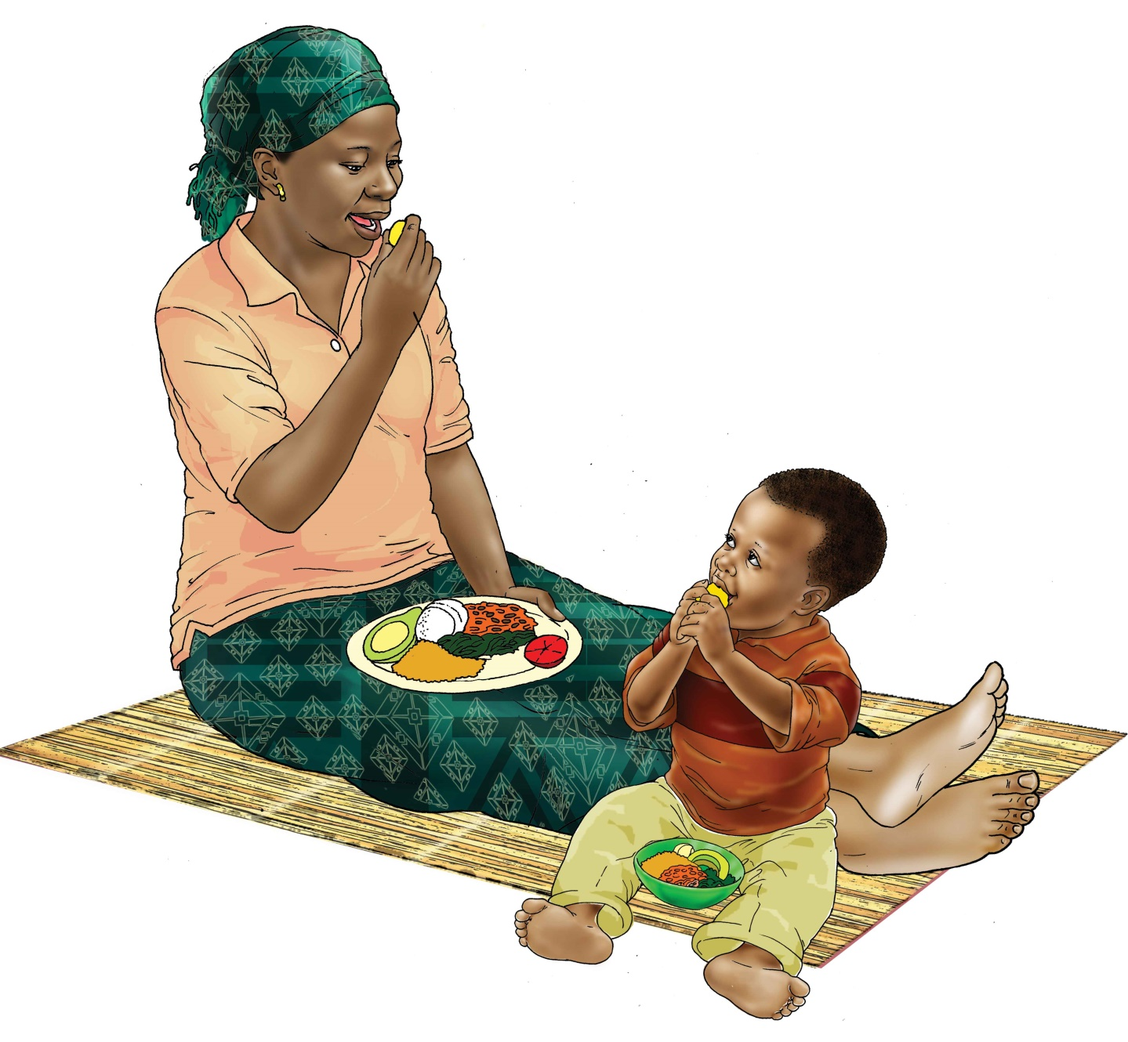

12–24 MONTHS
365 DAYS
CONTINUED BREASTFEEDING
INCREASED FREQUENCY OF COMPLEMENTARY FOODS

