Essential Nutrition Concepts for Nutrition-Sensitive Agriculture Activities
Session Guide Two of the Nutrition-Sensitive Agriculture Training Resource Package
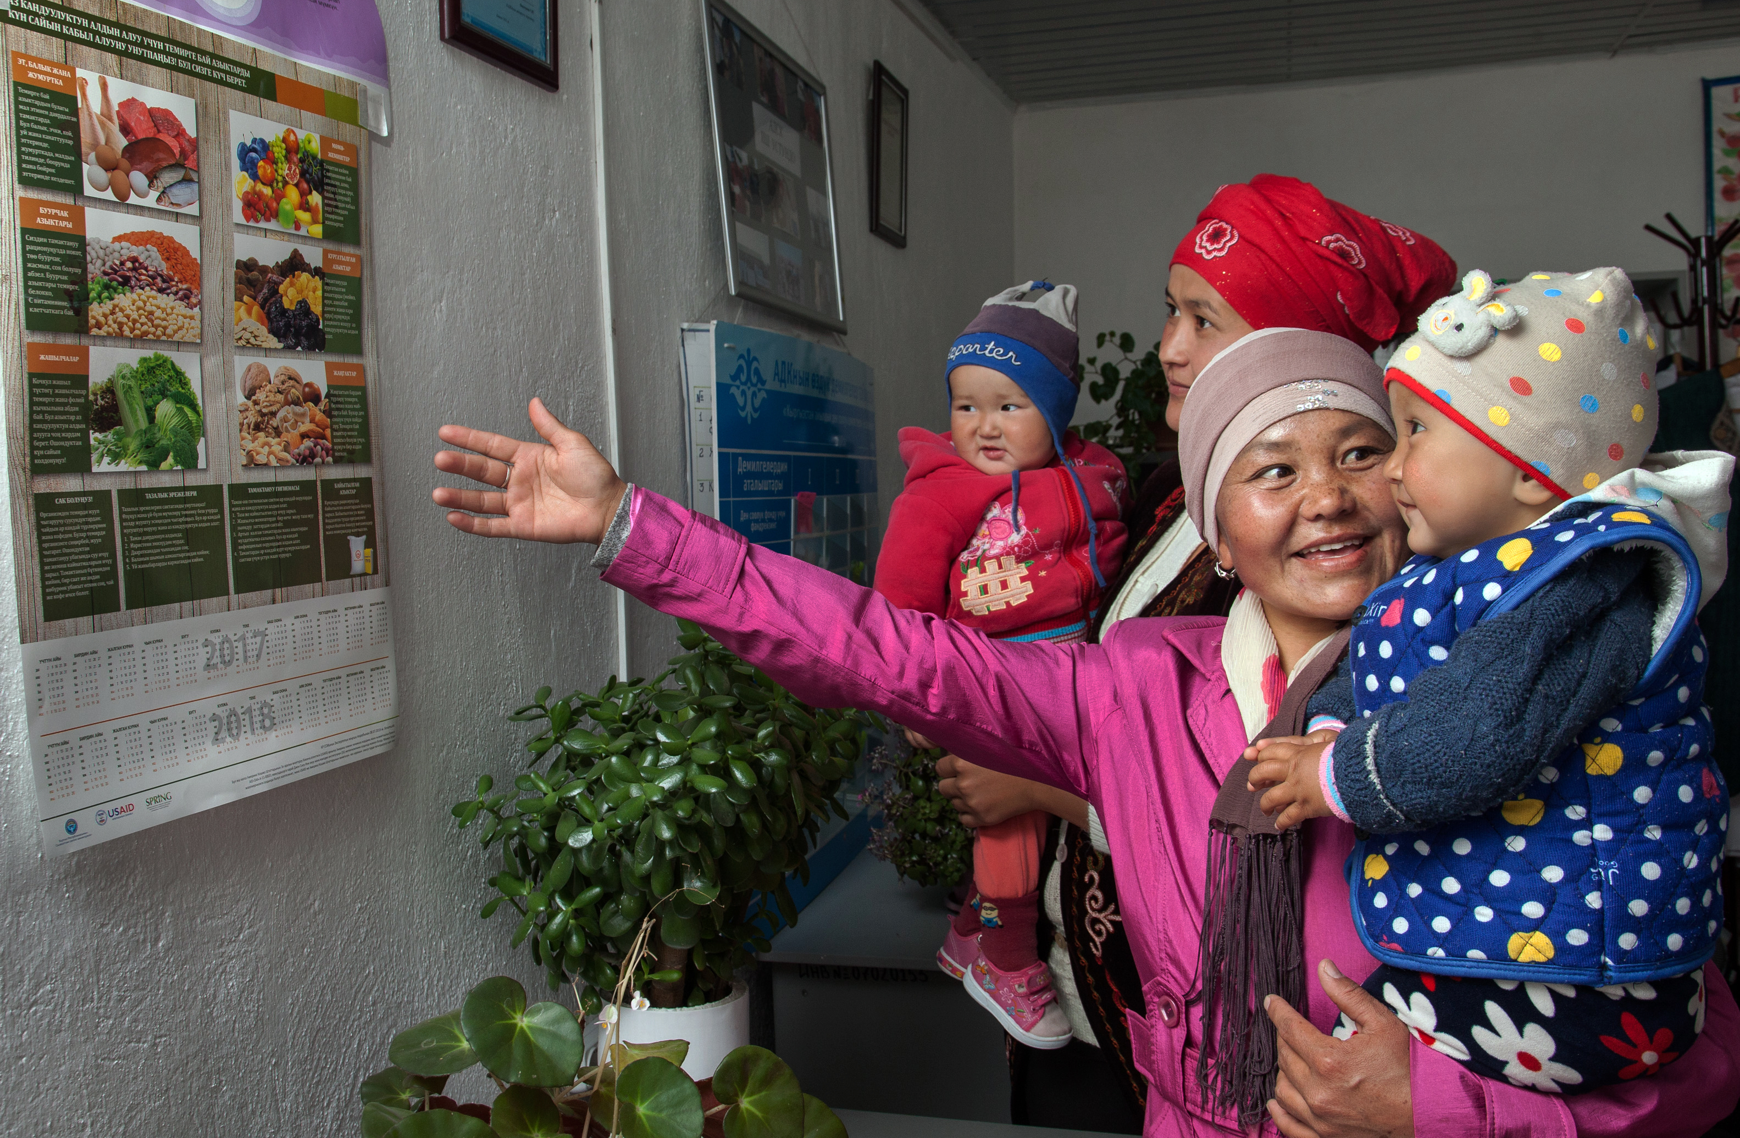

Essential Nutrition Concepts for Nutrition-Sensitive Agriculture Activities
Session Guide Two of the Nutrition-Sensitive Agriculture Training Resource Package

ABOUT SPRING
The Strengthening Partnerships, Results, and Innovations in Nutrition Globally (SPRING) project is a seven-year USAID-funded cooperative agreement to strengthen global and country efforts to scale up high-impact nutrition practices and policies and improve maternal and child nutrition outcomes. The project is managed by JSI Research & Training Institute, Inc., with partners Helen Keller International, The Manoff Group, Save the Children, and the International Food Policy Research Institute.
RECOMMENDED CITATION
SPRING. 2018. Essential Nutrition Concepts for Nutrition-Sensitive Agriculture Activities: Session Guide Two of the Nutrition-Sensitive Agriculture Training Resource Package. Arlington, VA: Strengthening Partnerships, Results, and Innovations in Nutrition Globally (SPRING) project.
DISCLAIMER
This report is made possible by the generous support of the American people through the United States Agency for International Development (USAID) and Feed the Future, the U.S. Government’s global hunger and food security initiative, under the terms of the Cooperative Agreement AID-OAA-A-11-00031 (SPRING), managed by JSI Research & Training Institute, Inc. (JSI). The contents are the responsibility of JSI and the authors, and do not necessarily reflect the views of USAID or the U.S. Government.

SPRING
JSI Research & Training Institute, Inc.
1616 Fort Myer Drive, 16th Floor
Arlington, VA 22209 USA
Phone: 703-528-7474
Fax: 703-528-7480
Email: info@spring-nutrition.org
Internet: www.spring-nutrition.org

COVER PHOTO: SPRING/Kyrgyz Republic

Contents
Preparing to Present This Session 1
Purpose 1
Objectives 1
Estimated Duration 1
Materials 1
Core Content 3
Exercise: Breaking the Cycle of Malnutrition 9
Additional Exercises 13
Exercise 1: The First 1,000 Days 13
Exercise 2: What Mothers and Children Need 15
Exercise 3: Other Important Practices 18
References 21
Additional Resources 21

Preparing to Present This Session
Purpose
This is Session Two of seven that are included in the Nutrition-Sensitive Agriculture Training Resource Package.
This session creates the foundation in nutritional principles and practices that is necessary to understand the root causes of malnutrition. The concepts here focus on the importance of the “first 1,000 days,” maternal and young child nutrition, and how to break the cycle of malnutrition. This session is most comprehensive when it is delivered by a nutritionist or someone with extensive knowledge in nutrition.
The content included here explains nutrition concepts in detail, and can be used either as a review of essential information for experienced nutritionists or as a foundation in nutrition for agriculturalists.
Objectives
By the end of this session, participants will be able to—
- describe five forms of malnutrition
- analyze the essential needs of infants, children and mothers, especially during the period from conception to the child’s second birthday (the “first 1,000 days”)
- identify strategies for interrupting the cycle of malnutrition.
Estimated Duration
1.5 hours, additional time may be needed if the additional exercises are used
Materials
All documents needed to deliver the session can be found at https://www.spring-nutrition.org/nutrition-sensitive-ag-training/session2.
- PowerPoint presentation: 2. Essential Nutrition Concepts
- Tape or other method for fixing paper to the wall
- Other Materials
- Handout: Five forms of malnutrition- summary sheet
- Handout: UNICEF framework
- One copy to post on the wall: First 1,000 days cards (choose Guinea or India, whichever is more appropriate for your audience)
- For the facilitator: First 1,000 days answer key
- Handout: Breaking the cycle of malnutrition- summary sheet
- The following are for optional exercises:
  - One copy to post on the wall: Illustrations of mother, baby, and care practices
  - One copy of each illustration for posting on the wall: Illustrations of other important practices

Core Content
Slide 1 (cover) Essential Nutrition Concepts for Nutrition-Sensitive Agriculture
- The impact of nutrition on every society is significant: Children who do not receive good nutrition early in life are at risk for early mortality and poor growth and development.
- Improving nutrition can drive economic growth for the family and for the country. In several African countries studied, every $1 investment in reducing chronic undernutrition in children yields an estimated $16 return in increased capacity and productivity (Hoddinott 2016).

Slide 2 Nutrition Elements of the Pathways
- In Session One (Strengthening Agriculture-Nutrition Linkages: Why It Matters), we discussed key evidence about the importance of nutrition and outlined how agriculture activities can become more nutrition-sensitive.
- We highlighted the three main linkages between agriculture and nutrition—food produced, income generated and the use of women’s time and energy.
- In later sessions, we will discuss these three pathways in greater detail and focus on specific agriculture-nutrition linkages.
- This session will focus specifically on the nutrition elements of these pathways. Creating a solid foundation in nutrition, we will explore what women and children need to have well-nourished bodies and healthy, productive lives.

Lessons Learned: In several countries, participants expressed concerns about working across sectors, often describing their concerns in this way: “I am a livestock specialist, focused on creating economic growth—let’s leave nutrition to the nutritionists.” To overcome this sector-specific thinking, we designed content that focuses on guiding participants to more clearly see agriculture-nutrition links and identify gaps. Specifically, exercises that prompt participants to “draw your activity,” or “draw your community,” and then guides them to analyze nutrition links that may be missing. This results in a more concrete understanding of how activities within a given context can be made more nutrition-sensitive.

Slide 3 Objectives
- Describe five forms of malnutrition.
- Analyze the essential needs of infants, children, and mothers, especially during the period from conception to the child’s second birthday (the “first 1,000 days”).
- Identify strategies for interrupting the cycle of malnutrition.

Slide 4 Nutrition Is Critical for Growth and Development
- Nutrition has an important impact worldwide, especially on children. Globally, 45 percent of all child deaths are due to malnutrition (IFPRI 2016).
- There are many other short-term and long-term consequences for children who experience nutrition problems at some point in their lives:
  - Children who are under-nourished are more likely to become ill, and are less able to fight off infection. The Lancet series on undernutrition found that 11 percent of the global disease burden is due to maternal and child undernutrition (Black et al. 2008).
  - Malnutrition leads to lower human capital. Stunting among children at two years of age is associated with lower school performance and reduced earnings later in life (Victora et al. 2008).
  - Countries with high rates of malnutrition suffer reduced economic growth and development. Across Asia and Africa, countries lose 11 percent of gross national product every year due to poor nutrition (Black et al. 2013; Horton and Steckel 2013; IFPRI 2016; Lim et al. 2012).
  - Overweight and obesity, in both children and adults, increases the risk of chronic diseases such as heart disease and diabetes.
- By addressing malnutrition, we can not only decrease child mortality, but also increase cognitive, motor, and socio-emotional development of children; increase school performance and learning capacity; increase adult stature; decrease adult obesity; and increase work capacity and productivity.

Slide 5 Five Forms of Malnutrition
- Malnutrition is a general term that includes nutrient deficiencies, undernutrition, and over nutrition. Undernutrition and over nutrition are usually defined by comparing an individual’s height, weight, or other measurement with the average height or weight for a healthy population of the same age and sex.
  - Wasting (acute undernutrition) refers to weight that is too low for an individual’s height, and may sometimes be described as thinness. Wasting is what we typically see among communities experiencing famine and among families who struggle to get enough food.
  - Stunting (chronic undernutrition) refers to height too low for age, and can also be described as short stature. Stunting can be much harder to see—a stunted child may look healthy, but is noticeably short for his age.
  - Underweight refers to weight too low for age. This measure is not recommended as a measure for nutrition programs, as it can include children who are stunted, wasted, or just small for their age.
  - Overweight or obesity refers to weight that is too high compared to an individual’s height. It is typically measured using body mass index (BMI), a measurement that compares weight with height and determines a set BMI value. An individual with a BMI greater than 25 is considered overweight, while someone with a BMI greater than 30 is classified as obese.
  - Micronutrient deficiency means that an individual is receiving insufficient amounts of the vitamins and minerals that are essential for growth and health. Globally, iron deficiency, Vvtamin A deficiency, and iodine deficiency are the most common types of micronutrient malnutrition.

Facilitator Note: Hand out “Five Forms of Malnutrition” summary sheet.

Slide 6 Five Forms of Malnutrition (images)
- Remember: malnutrition doesn’t “look” one specific way. When we look at children who are malnourished, their appearance can vary.
- In many cases, we wouldn’t know that a child is malnourished unless we ask the right questions, such as, “How old is this child?” In the case of micronutrient deficiency, there may be no visible signs, and a blood test or other physical assessment may be needed to identify the problem.

Lessons Learned: Some stakeholders may have difficulty recognizing nutrition problems that exist in their own country or community, either because they are unaware or because they hold misconceptions about what malnutrition “looks like.” By using locally relevant statistics, the facilitator can highlight the most common types of malnutrition in a stakeholder’s zone of influence. Such research can be used throughout this session to ensure that participants understand and see the evidence for specific nutrition-related problems that their programs should be focusing on. Grounding nutrition concepts in facts helps drive action.
For example, some stakeholders in the Kyrgyz Republic did not realize that malnutrition—particularly anemia—was a significant problem. When they looked at what children were eating (colorful, diverse foods, and meat), they doubted that there was a nutrition problem to solve.
Focusing on locally specific nutrition problems helps each stakeholder more clearly see the issues our activities strive to address.

Slide 7 What Works to Reduce Undernutrition?
- We have a solid understanding and clear evidence base of what is referred to as nutrition-specific interventions—those that address immediate causes of undernutrition

Slide 8 What Works to Reduce Undernutrition? (animated slide)
- The interventions that address the immediate causes of undernutrition—the nutrition-specific interventions—include:
- Infant and young child feeding and essential nutrition actions. (e.g., breastfeeding, complementary feeding.)
- Providing micronutrients that are most commonly deficient (e.g., iron/folate for pregnant women, vitamin A to young children where contextually appropriate.)
- Integrated management of childhood illness. This community-based approach to addressing less serious childhood illnesses empowers communities to understand and respond to sick children’s needs.
- Community management of acute malnutrition. This community-based approach seeks to address severe acute malnutrition, or wasting, through the community rather sending the child to a hospital.
- Even if we can scale up these interventions to cover 90 percent of the at-risk population it would ONLY address 20 percent of chronic malnutrition (stunting). So, what more is needed?

Slide 9 The UNICEF Framework: Reducing Malnutrition (animated slide)
- This UNICEF (2015) framework was designed to describe the causes of malnutrition. Under this framework, two immediate causes of malnutrition are identified: inadequate nutrient intake and health status.
- As we just saw, there are a range of approaches to address the immediate causes of malnutrition—the nutrition-specific interventions.
- Approaches that address the underlying causes of malnutrition—problems related to food, health and care—are referred to as nutrition-sensitive.
- At the base of the framework, we see the basic causes of malnutrition, which include the policy and legal framework that nutrition interventions operate in, and the cultural and gender norms that influence behaviors.
- If we are to comprehensively address malnutrition, we need approaches that target both immediate and underlying causes. Nutrition-sensitive agriculture is one intervention in a range of responses needed to reduce malnutrition.
  - A review of countries that have successfully reduced stunting found that a combination of nutrition-specific and nutrition-sensitive improvements (such as safe water, women’s education, and access to food) played important roles, combined with income growth and better governance (Smith and Haddad 2015).
  - We will discuss the underlying causes of malnutrition and nutrition-sensitive agriculture in greater detail in Session Four (Agriculture-to-Nutrition Pathways).

Facilitator Note: Hand out “UNICEF Framework.”

Lessons Learned: In a 2017 SPRING training workshop for community workers, we avoided using structured frameworks and models like these. But we found ourselves drawing this UNICEF nutrition framework freehand on the flipchart, because it was the clearest and most succinct way to talk about the causes of malnutrition.

Lessons Learned: As one discusses the UNICEF framework, it is important to acknowledge that some agriculture activities have been doing nutrition-sensitive agriculture (and addressing basic and underlying causes of malnutrition) for a long time, without using that terminology. The aim of this discussion is to make explicit linkages between agriculture activities and nutrition outcomes that focus on underlying and basic causes. Using a workshop activity to help participants understand the differences between direct, underlying, and basic causes of malnutrition might be helpful.

Slide 10 Reaching Children at the Right Time (Note that slide is animated)
- This graph represents the average height-for-age from 54 countries (Victora et al. 2010).
  - The horizontal line represents the standard normal average for each age.
  - The blue line represents the average height-for-weight at each age from studies in 54 countries.
- Looking at the blue line, what do you notice?
  - During gestation and the first two years of life, nutritional requirements are very high to support rapid growth and development of the infant.
  - In many regions of the world, average height-for-age (z-scores) are already low at birth and then decline sharply during the first 24 months of life.
  - After two years, these children show no further decline, nor any improvement.
- The most effective interventions to prevent stunting take place during the window of opportunity: the first 1,000 days of life (conception to 24 months of age). After that point, most of the effects of stunting are irreversible.
  - If we can prevent stunting before 24 months of age, then the child has a much greater chance of succeeding at school and at earning a living as an adult.

Facilitator Note: Participants may notice a steep increase in stunting between months 0 and 1 on the graph. That is because these graphs are based on household survey data, so the earliest measurements are from when a child is already a few weeks to a month old. Some children are, in fact, stunted at birth (i.e., small for gestational age), but do not appear on this graph, due to the lack of birthweight measurements.

Slide 11 Good Nutrition for the Mother and the Infant Is Critical
- Remember: throughout the first 1,000 days, the mother’s nutrition is essential for the child’s survival.
- Her health affects the child’s during pregnancy and breastfeeding, and her ability to care for the infant depends on her good health. When a mother is malnourished, she is less able to support the nutrition of her infant.

Slide 12 Recommended Exercise: The First 1,000 Days
Designed to encourage reflection on correct feeding and care practices from conception to two years of age, this 20-minute, small group activity is built around illustrations of the stages of infant feeding and care. The activity is well-suited for community-level and national-level participants in a range of cultural contexts. (Sample illustrations are from India and Guinea. Feel free to replace them with images relevant to your local context).
For more detailed activity instructions, click the link above.

Lessons Learned: Interactive facilitation methods (role play, competition) help participants think about nutrition-sensitive agriculture concepts more concretely. Additionally, specific activities can help draw out contextually specific information. For example, when we created daily activity charts for each member of the household in India, assumptions about how men and women spend their days helped reveal how local beliefs and practices affect family members’ nutrition.

Slide 13 Recommended Exercise: What Mothers and Children Need
Designed to focus on essential care practices for mother and child, this 20-minute activity uses illustrations to create a care map that details their needs, followed by an analysis of common practices in the community. This activity is well-suited for community-level and national-level participants.
For more detailed activity instructions, click on the link above

Slide 14 The Cycle of Malnutrition (animated slide)
- In addition to the overall health of the infant and mother, we see another nutrition issue that is important. Malnutrition can be cyclical.
- It can start with an undernourished pregnant woman. What are the consequences of being undernourished at this stage?
  - The mother does not get the nutrition her body needs, so very often, we find that …
- Her infant is also undernourished. What are the consequences here?
  - All too often, that undernourished infant grows up to become …
- An undernourished child. And the consequences here?
  - This child grows up to become an undernourished adolescent. What are the consequences of being undernourished during adolescence? The adolescent may grow up to become …
- An undernourished adult woman, who may continue to be undernourished through her own pregnancy.
- When an undernourished adolescent becomes pregnant, the cycle can be shortened even more:
  - The teenage mother and the growing baby compete for nutrients.
  - The teenager is at risk for a more difficult labor and higher rates of maternal mortality.
- We are here to work together to explore the many opportunities to break this cycle at each stage.

Facilitator Note: Hand out the “Breaking the Cycle of Malnutrition” summary.

Lessons Learned: Context-specific examples are especially important for explaining nutrition. Current research on malnutrition in the activity area is essential for appropriately illustrating nutrition-sensitive agriculture concepts. For example, during a SPRING training workshop in Guinea, participants mentioned cowpeas as a nutrient-rich, locally available food that many pregnant and lactating mothers already consume and find appealing. The facilitator incorporated this locally available nutritious food into the training sessions by talking about methods of incorporating more cowpeas into the regular diets of pregnant and lactating women.

Exercise: Breaking the Cycle of Malnutrition
About this Exercise
- Goal: Discuss strategies for breaking the cycle of malnutrition at each stage of life.
- Duration: 30 minutes
- Materials: Flipchart paper
- Preparation: On three pages of flipchart paper, write the headings (one heading per page): Infants and Young Children, Adolescence, and Adult Woman.
Exercise Instructions
- Divide the training group into three teams. Assign one stage of life to each group.
- Give the following instructions:
  - Consider the stage of life that you were given. What can be done at this age to ensure that the child/adolescent/adult woman is well nourished?
  - Take about 10 minutes to brainstorm key practices. Note these key practices on your sheet of flipchart paper.
- As teams brainstorm, the facilitator should circulate among the groups, encouraging them to consider practices related to diet, preventing illness, addressing illness, and other practices that could help or harm a woman’s health.
- Give each group five minutes to share their responses. Ensure that the items in the answer key below are mentioned for each group.
Answer Key
Breaking the Cycle: Infants and Young Children
- Encourage early initiation of breastfeeding, within one hour of birth. This helps establish breastfeeding practices early on, and ensures that babies receive colostrum, the “first milk” which is full of nutrients and antibodies to give babies the best start in life.
- Practice exclusive breastfeeding until the child is 6 months of age. Exclusive breastfeeding means that no other foods or fluids are given to the baby, except for needed medicines.
- Encourage timely introduction of complementary foods at 6 months of age, with continuation of breastfeeding up to 2 years or beyond. (No other food is needed in the first 6 months.)
- Sick children require extra food and fluids to help them recover, and should be fed frequently during illness, and for 2 weeks after recovery.
- Children with severe acute malnutrition are at immediate risk of mortality and should be taken to a health facility for assessment and treatment. Most of these children can then be treated at home using special therapeutic foods.
- For the mother, using iodized salt in place of regular (non-iodized) salt helps ensure that the breastfeeding infant gets iodine, which is important for cognitive development.
- The mother should attend growth monitoring, promotion and immunization sessions.
- Pregnant women and children should use insecticide-treated nets in areas where malaria infection occurs.
- Regular clinic visits are important for prevention and timely detection and treatment of common illnesses, such as pneumonia, diarrhea, and malaria, and for deworming.
- Vitamin A supplementation is recommended in areas where vitamin A deficiency is a public health problem.
Breaking the Cycle: Adolescence
- Increase food intake: Teenage girls need to eat at every meal.
- Encourage parents to give girls and boys equal access to education. Malnutrition decreases when girls and women receive more education.
- Encourage families to delay marriage for young girls.
- Delay first pregnancy until the mother’s own growth is completed (usually 20–24 years of age) will help to reduce complications for the infant and mother. This may relate to delaying the age of marriage.
Breaking the Cycle: Adulthood
- Visit a family planning center to discuss which family planning methods are available and most appropriate for the individual’s situation. Using a family planning method is important to adequately space births for the health of the mother and children. It is recommended that women space pregnancies two years apart.
- Ensure eight health system antenatal contacts. Updated WHO guidelines increased the recommended number of contacts a pregnant woman should have during her pregnancy from four to eight because of evidence that additional visits/contact reduces the risk of stillbirth. Antenatal care is a critical opportunity for health providers to deliver care, support, and information to pregnant women (WHO 2016).
- Increase food intake during pregnancy and breastfeeding. During pregnancy, this means eating one extra meal or “snack” (food between meals) each day; during breastfeeding, it means eating two extra meals or “snacks” each day.
- A pregnant woman should take iron/folate supplementation (or other recommended supplements for pregnant women) as soon as she knows she is pregnant and continue for at least three months after delivery of the child, according to national recommendations.
- Deworm and giving antimalarial drugs to pregnant women at 4+ months of pregnancy.
- Prevent, educate, and test for sexually transmitted infections, including HIV.
- Let other members of the family help with the pregnant woman’s workload.
- Rest more, especially during late pregnancy.

Slide 15 A Diverse, Healthy Diet is Needed at all Stages of Life
- Steps can be taken at each stage of life to break the cycle of malnutrition. Each stage is important for healthy development.
- This includes eating a diet from a diverse range of sources. Families should aim to provide children with foods from four or more food groups each day, and eat a range of healthy foods throughout the week.
  - Animal-source foods, such as chicken, fish, liver, eggs, milk, and milk products.
  - Staples: grains, such as maize, rice millet, and sorghum; roots and tubers, such as cassava and potatoes.
  - Legumes, such as beans, lentils, peas, and groundnuts; seeds, such as sesame.
  - Fruits and vegetables rich in vitamin A, such as mango, papaya, passion fruit, oranges, dark-green leaves, carrots, sweet potato, pumpkin; and other fruits and vegetables, such as banana, pineapple, watermelon, tomatoes, avocado, eggplant and cabbage.
  - Oil and fats, such as oil seeds, margarine, ghee, and butter added to vegetables, and other foods will improve the absorption of some vitamins and provide extra energy. Infants need only a very small amount (no more than half a teaspoon per day).
- Can a malnourished mother still breastfeed her infant?
  - Yes – the mother’s body is still able to create breastmilk of good quality, even to the detriment of her own health. The benefits of breastfeeding still outweigh alternative feeding sources for the infant, though our goal is to have well-nourished mothers and infants.
- Practice appropriate hygiene, such as using latrines, keeping food and water containers clean, and washing hands before eating or preparing meals.
- Prevent and seek treatment for infections early.

Facilitator Note: The image on the previous slide should reflect the context in which participants work, especially the food on the plate. Some images are available for use in the SPRING Image Bank (https://iycf.spring-nutrition.org/), which has some context-specific diverse diet and meal images.

Slide 16 Other Family Members Help Break the Cycle
Discuss: How can husbands/partners help break the cycle of malnutrition? [Take several responses.]
  - Provide extra food for their wives/partners during pregnancy and lactation.
  - Help with household chores to reduce wives’/partners’ workload.
  - Encourage their wives/partners deliver the baby at health facility.
  - Arrange for safe transportation to a facility (if needed) for delivery.
  - Encourage their wives/partners to breastfeed immediately after birth and to give breastfeeding precedence over other household and agriculture responsibilities
  - Prioritize giving diverse foods, including small amounts of animal source foods, to children older than 6 months of age on a regular basis.
  - Discuss options for family planning together with their wives/partners.
  - Encourage equal access to education for girls and boys.
  - Accompany their wives/partners to antenatal care; remind them to take iron/folate tablets.
Discuss: How can female elders (mothers, grandmothers, in-laws) participate in breaking the malnutrition cycle for women and children? [Take several responses.]
  - Accompany the pregnant woman to antenatal care and remind her to take iron/folate tablets.
  - Provide extra food for the pregnant woman/new mother during pregnancy and lactation.
  - Help with the pregnant woman/new mother with household chores to reduce her workload.
  - Encourage the pregnant woman to deliver at health facility.
  - Encourage breastfeeding immediately after birth, and provide continued support to mothers to exclusively breastfeed for the first six months.

Slide 17 Suggested Exercise: Other Important Practices
Designed to promote reflection on non-feeding practices that impact nutrition, this 20-minute exercise uses illustrations to prompt local examples related to WAS), safe food handling, and use of health services.
For more detailed exercise instructions, click the link above.

Slide 18 Other Important Practices
- In our discussions about maternal and child health, and particularly maternal and child nutrition, we have focused mostly on practices that relate to food quantity and quality—eating the right foods, in the right amounts, at the right time.
- Other essential practices can also contribute to the nutritional status of mothers and children, including:
  - WASH
  - Food safety
  - Health and health services.

Slides 19-20 Key Points from this Session
- Five common forms of malnutrition include: wasting, stunting, underweight, overweight, and micronutrient deficiency.
- The most critical time in a child’s development is from conception to 2 years of age—this is referred to as “the first 1,000 days.”
- Addressing the cycle of malnutrition can be challenging. A malnourished child may become a malnourished adolescent. That adolescent may become a malnourished woman who becomes pregnant and gives birth to a malnourished baby.
- Everyone in a family has a role to play in breaking the cycle of malnutrition.
- Even when food is scarce, it is critical to make sure that infants and mothers eat. Good nutrition early on will have a life-long impact.

Additional Exercises

Exercise 1: The First 1,000 Days
About this Exercise
- Goal: Explain correct feeding and care practices during the first 1,000 days.
- Duration: 20–30 minutes
- Materials: First 1,000 days cards + Answer key—one copy for the whole group; tape or other method for fixing illustrations to the wall
- Preparation: During this exercise, be aware that there are many food taboos, conceptions/misconceptions, beliefs, and practices that drive the behavior of pregnant women and their family members during the first 1,000 days.
  - Encourage participants to correct one another, discuss viewpoints, and provide justifications for their thinking. Try to let participants figure it out themselves, but be sure to pay attention and address any misconceptions directly.
  - If you have time to discuss beliefs in greater depth, additional activities are available in the Maternal, Infant, and Young Child Nutrition Facilitator Guide, Session Eight: Beliefs and Food Taboos during Pregnancy and Breastfeeding. The document can be found here: https://www.spring-nutrition.org/sites/default/files/publications/series/cvng_appendix_3_facilitator_guide.doc

Facilitator Note: You can find the images for this exercise online at https://www.spring-nutrition.org/nutrition-sensitive-ag-training/session2. These images are context-specific, and there are two versions: Guinea and India. You may need to change them to reflect the country, culture, and common practices of the area where they will be used.

This exercise complements the participants’ understanding of the following core concept:
- Reaching Children at the Right Time
Exercise Instructions
- Divide the training group into six teams. Give each group one card with an illustration on it. Ask them to discuss the picture in their teams and decide:
  - What is happening in the scene? Why do you think it is important?
  - Where do you think your photo fits in the first 1,000 days—from conception until age 2?
- Together with the other teams, create the correct sequence on the wall, taping the pictures in the correct order. Once this is done, ask each group to explain:
  - What is happening on your card? Why do you think it is important? Why did you choose this location for the card?
- Explain that the first 1,000 days are very important: this is the period when the most critical brain and physical growth happens for an infant. Good health, nutrition, and care practices are very important during this period to make sure babies grow and reach their full physical and mental potential.
- The facilitator should add the remaining cards (words that describe each stage) over the correct images. If participants have made any errors in the order, be sure to explain and move the images into the correct order.
- These stages may not be well understood in the communities where we work. Correct feeding and care practices during the first 1,000 days are essential.
Answer Key
- Review the correct answers to the exercise below.
- Emphasize that understanding when to switch from one type of food to another is not intuitive or easy—especially when well-intentioned family members may offer the wrong advice.
- However, the actions a mother takes in this period are critical for her child. The first 1,000 days are nutrition’s window of opportunity.
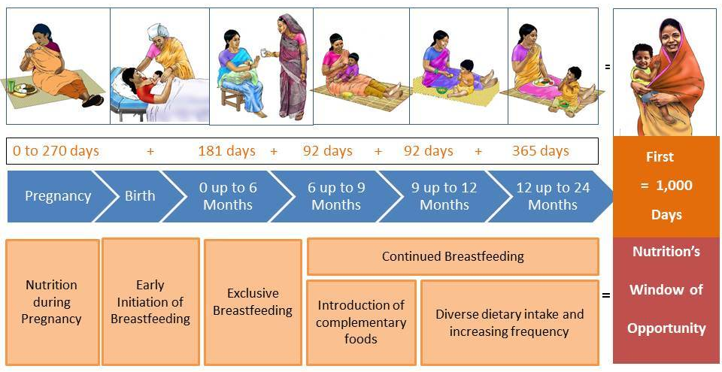

Lessons Learned: Across contexts, this exercise has prompted discussion on norms and practices at each stage of the first 1,000 days. Facilitators have found it extremely important to listen to groups’ discussion during this exercise. Facilitators will play a key role in intervening to address misconceptions, discuss drivers of these misconceptions, and share the rationale behind key practices in each stage of the first 1,000 days. Listening to these conversations will also provide facilitators with an opportunity to learn more about the context of the training’s participants.

Exercise 2: What Mothers and Children Need
About this Exercise
- Goal: Discuss essential care practices for a well-nourished mother and child.
- Duration: 20–30 minutes
- Materials: Illustrations of mother, baby, and care practices, two large blank pieces of flipchart paper, tape or other method for fixing illustrations to the wall
- Preparation:
  - Print copies of the illustrations and identify a clear space on the wall to stick the images and to tape a large flipchart-sized blank paper.
  - Tape an illustration of a healthy, well-nourished mother on a large piece of paper in the center of the page, leaving room to add pictures below and around the picture.
  - Tape the illustration of the baby on another large sheet of blank paper in the same manner.
  - Be prepared to encourage participants to correct one another, discuss viewpoints, and provide justifications for their thinking. Try to let participants figure it out themselves, but be sure to pay attention and address any misconceptions directly.
Facilitator Note: You can find the images for this exercise online at https://www.spring-nutrition.org/nutrition-sensitive-ag-training/session2. These images are context-specific, and there are two versions: Guinea and India. You may need to change the images to reflect the country, culture, and common practices of the area where they will be used.

This exercise complements the participants’ understanding of the following core concepts:
- Good Nutrition for the Mother and Infant is Critical
Exercise Instructions
- Explain that we will start by talking about the mother. Ask participants:
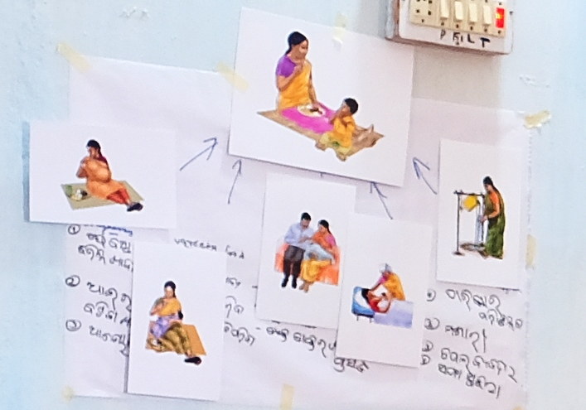
  - What kinds of care and support are needed to have a healthy mother who will give birth to, and breastfeed, a healthy baby?
Mother care map from training in India
- Participants should mention things such as:
  - Good diet, including additional food and a range of diverse food groups
  - Supportive health services and counseling
  - Supportive family
  - Time to rest and to care for the new baby
  - Clean water, hygiene, and sanitation
  - Micronutrient supplementation.
- As participants mention an item, show the corresponding illustration and tape it to the wall around the healthy mother. When all the pictures are taped to the page, draw arrows from the pictures to the healthy, well-nourished women (see the example photo as well as images below).
- Ask participants:
  - How does this “care map” compare to what is happening in your communities?
Discussion
- As a group, discuss and summarize the nutrition and care needs of mothers and children and their importance.
- Additionally, mothers need adequate rest to protect their health. When a mother has enough time to care for herself and her baby, both are healthier. Family members can play a role in supporting a mother’s physical and emotional needs, helping with household tasks, gardening, and working in the fields. This support helps ensure that a pregnant or nursing woman gets the rest and nutrients she needs to be healthy.
- Explain that having a healthy mother is important, and she will want to do the right things to ensure that her baby is also healthy.
- Explain that now we will talk about the baby. Ask participants:
  - What kinds of care and support are needed to ensure that the child is healthy?
- Participants should mention things such as:
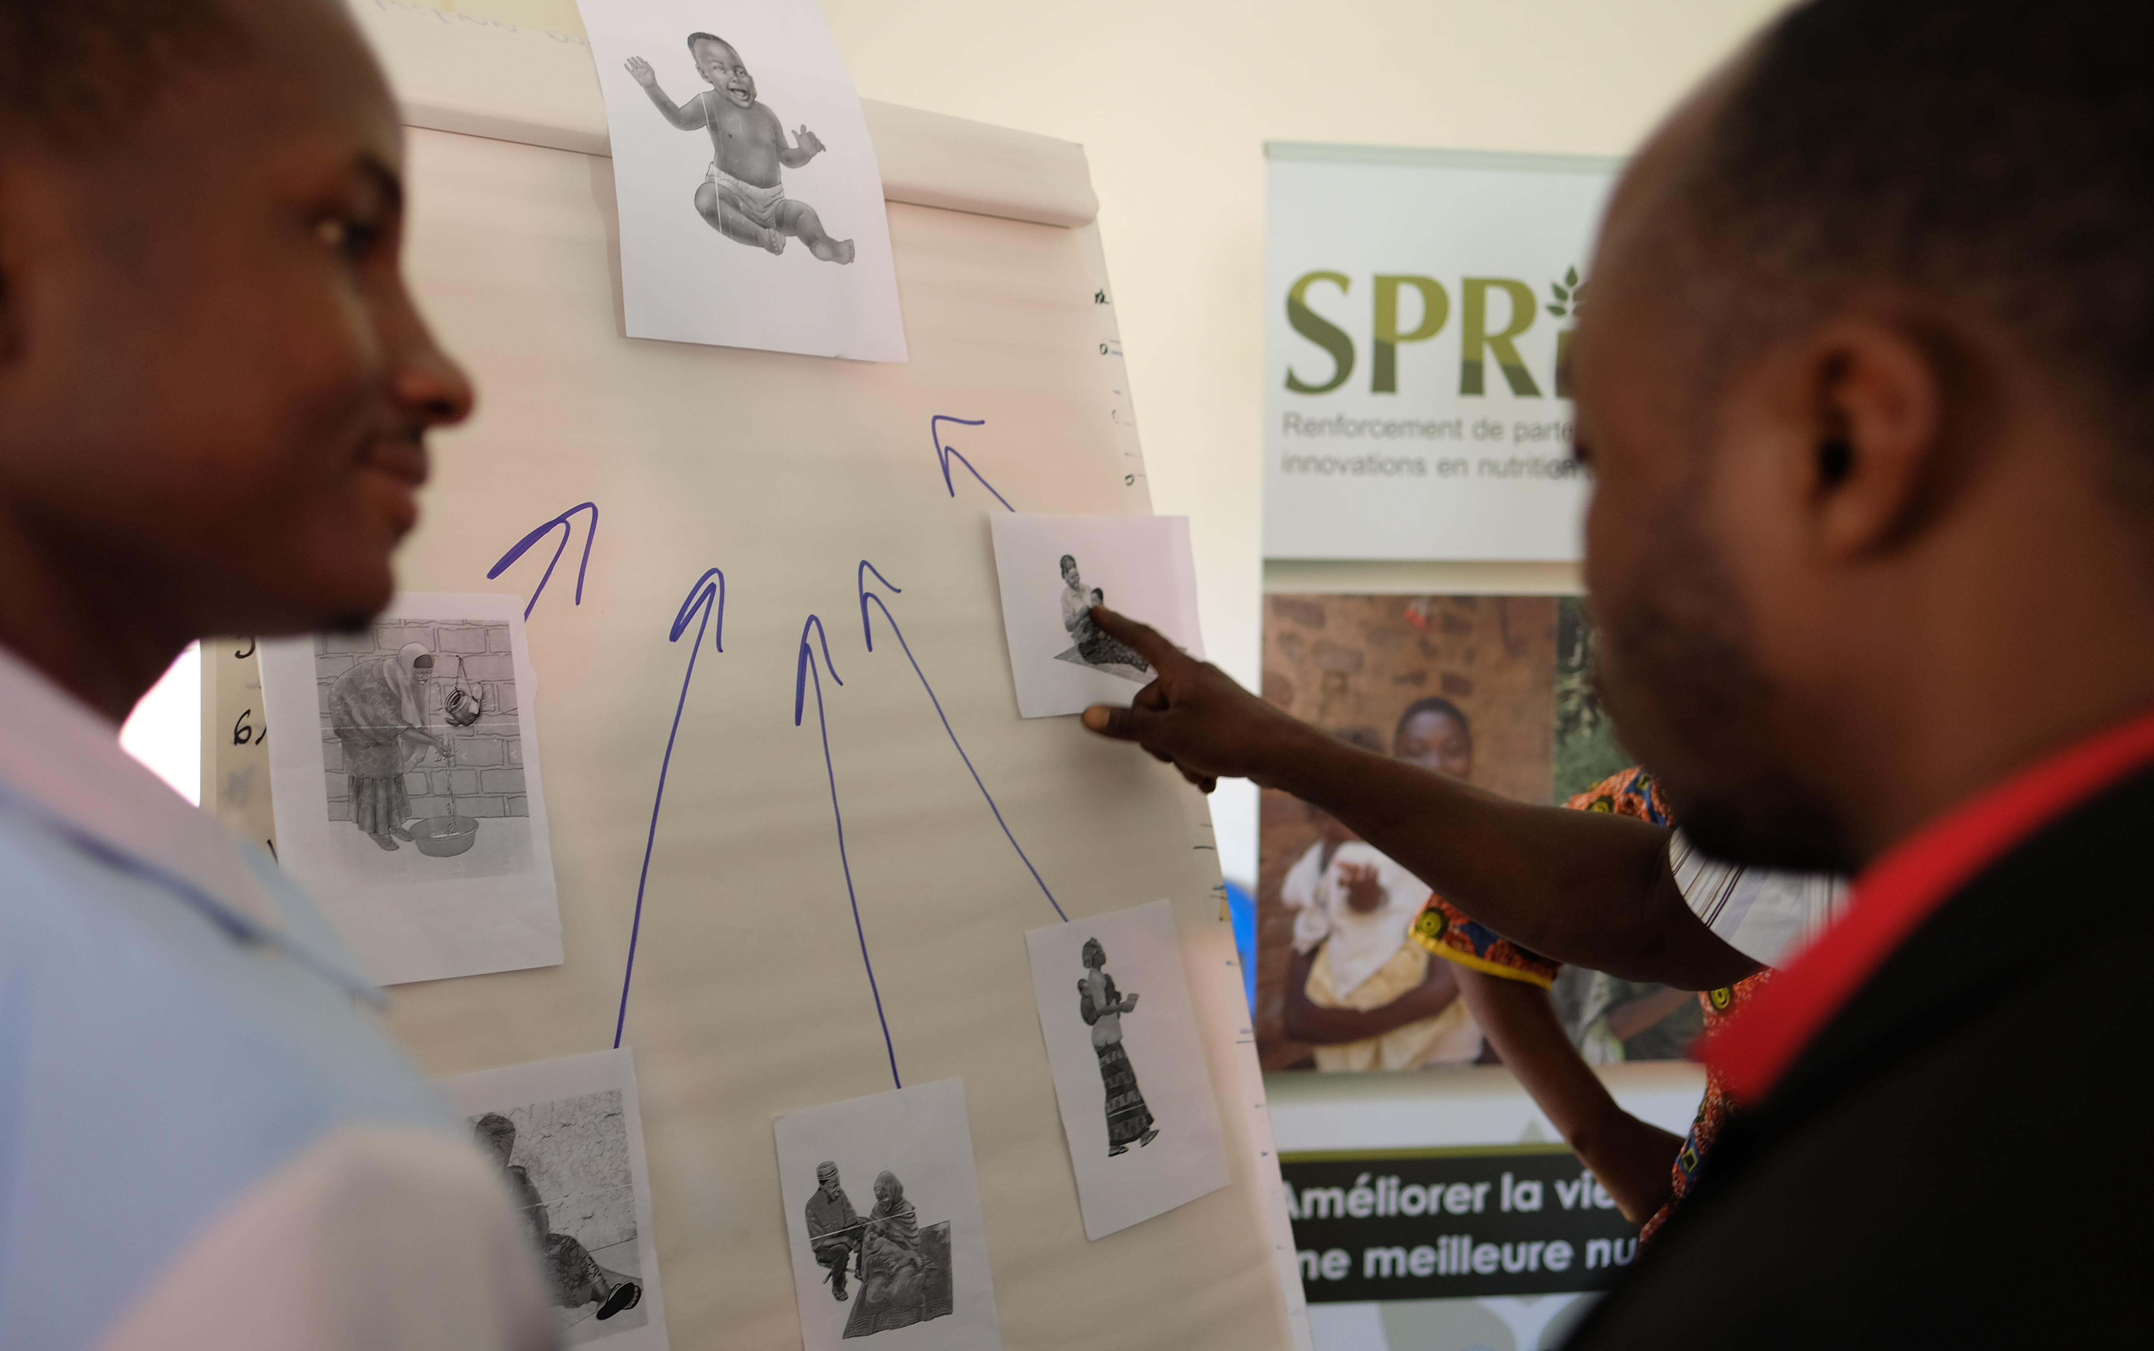
  - Healthy, well-nourished pregnant woman
Child care map from training in Guinea
  - Healthy well-nourished mother breastfeeding
  - Supportive family
  - Variety of foods
  - Care practices and health services
  - Clean water/hygiene/sanitation.
- As participants mention an item, show the corresponding illustration and tape it to the wall around the healthy baby. If participants miss something important, probe for the answer.
- When all the pictures are taped to the page, draw arrows from the pictures to the healthy, well-nourished baby (see the example photo as well as images below).
- Ask participants:
  - How does this “care map” compare to what is happening in your communities?
- Discuss as a group and summarize.
- In addition to nutrition, healthy babies need regular care and attention from the mother and other members of the family. Care is not just about what the infant eats; it is also about the amount of time she is held and played with and how well her needs are met.

Finished Care Maps (Examples)
The Mother
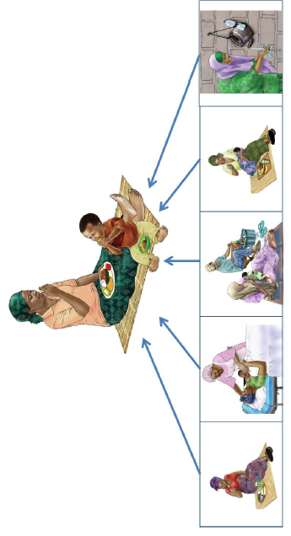
Nutrition and health of the woman | Health services | Care practices | Variety of food | Water, hygiene and sanitation
The Baby
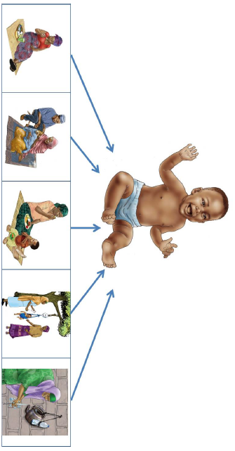
Nutrition and health of the woman | Care practices | Variety of food | Health services | Water, hygiene and sanitation

Lessons Learned: Similar to the first 1,000 days exercise, these activities are important to elicit discussions of norms surrounding each of the key practices that support maternal and infant health. The facilitator should listen closely to participants’ discussion throughout this exercise and ensure that any misconceptions about maternal or child health are discussed.

Exercise 3: Other Important Practices
About this Exercise
- Goal: Discuss specific practices that contribute to safe food handling and hygiene.
- Duration: 20–30 minutes
- Materials: Illustrations of other important practices; tape or other method for fixing illustrations to the wall
- Preparation: Choose illustrations that you would like for the exercise. Print one copy of each illustration. Divide the group into four teams, giving each team one illustration.
  - Encourage participants to correct one another, discuss viewpoints, and provide justifications for their thinking. Try to let participants figure it out themselves, but be sure to pay attention and address any misconceptions directly.

Facilitator Note: The images you need for the following exercise can be found online at https://www.spring-nutrition.org/nutrition-sensitive-ag-training/session2. These images are from various contexts. You may need to change the images that you use in your training to reflect the country, culture, and common practices of the area where they will be used. Images from other contexts that are relevant to this activity can be found online: https://iycf.spring-nutrition.org/.

This activity complements the participants’ understanding of the following core concepts:
- Other Important Practices

Exercise Instructions
- Instruct the groups to review the illustration they have received. Ask:
  - What are the recommended practices illustrated in each photo?
  - What instructions would you give a family to ensure that each practice is done well?
- When every group has finished discussing their illustration, they can place it on the wall. Call on each group to present its practice in turn, ensuring that all key points (below) are mentioned.
Answer Key
WASH
Good hygiene (cleanliness) is important to avoid diarrhea and other illnesses.
- Wash your hands with soap and clean running water before preparing foods and feeding your baby.
- Wash your hands and your baby’s hands before eating.
- Wash your hands with soap and clean water after using the toilet and after washing or cleaning your baby’s bottom.
- Feed your baby using clean hands, clean utensils, and clean cups.
- How to wash your hands:
  - Wet your hands with clean running water and apply soap.
  - Rub your hands together to make a lather and scrub them well.
  - Scrub the backs of your hands, between your fingers and under your nails.
  - Continue rubbing your hands for at least 20 seconds.
  - Rinse your hands well under running water.
  - Dry your hands using a clean towel, or air-dry them.
- Use safe water and ensure good compound hygiene. Drinking water needs to be boiled or treated so it is clean and safe and does not cause diarrhea. To ensure that water is safe to drink, do one of the following:
  - Boil it and let it continue boiling for 1 minute after large bubbles appear, and then keep it covered as it cools down.
  - Use water purification tablets or other water purifying additive as directed.
- Store water in clean, covered containers.
- Wash hands before collecting water from containers.
- Wash hands with soap before preparing the food and before touching the food.
Safe Food Handling
Contaminated food and water cause many diseases, such as diarrhea, typhoid, cholera, and hepatitis. Foods can become contaminated by contact with dirty hands, flies and other insects, mice and other animals, and dirty utensils. Young children and sick people are most vulnerable to food-related illness.
- Store utensils and food correctly:
  - Wash utensils with soap and keep them in the kitchen’s utensil cabinet.
  - Keep the cooked food in the safety net/cabinet to protect it from flies, dust, and other germs.
  - Keep dry foods such as rice and legumes in a dry cool place where they are protected from insects, rats, mice, and other pests.
- Prepare food safely:
  - Keep food preparation surfaces clean.
  - Cover any wounds on the hands before preparing food.
  - Do not spit near food and water.
  - Wash vegetables and fruits well before cooking or eating; if clean water is not available, peel when possible.
  - Prevent raw meat, offal, poultry, and fish from touching other foods. Wash surfaces touched by these foods with hot water and soap.
  - Give only freshly cooked food to children.
  - Cook fish and meat well to kill any germs or parasites. For infants and small children, cook the food until it is soft and mash it or chop it into very small pieces.
  - Do not eat raw or cracked eggs, because they may contain harmful germs that can cause illness.
  - Always reheat leftover food before eating.
- Choose the freshest foods for consumption. Do not eat moldy or rotten foods.
- Use proper approaches for feeding infants and children.
  - The use of bottles, teats, or spouted cups for babies and young children is not recommended since they can be easily contaminated and are difficult to clean.
  - Use a clean spoon or cup to give foods or liquids to your baby.
- It is crucial to keep the home and the compound clean and free of feces and rubbish.
  - A child’s feces can spread illness, just like an adult’s. Before a child is old enough to use a latrine, you need to throw the child’s feces into the latrine or bury it.
  - Keep animals in a separate place, away from the family living area. Animals should not sleep in the same house with the family.
  - Latrines should not be constructed close to the family living area. The latrine should be kept clean and the pit must be kept covered.
Health Care
- If the mother or child shows sign of illness, s/he should go to the clinic right away. Infant maladies can worsen quickly, and getting immediate advice from a clinician can ensure that problems are treated.
- Promote savings to make sure that the family has money for planned and emergency visits to the clinic.

References
Black, Robert E., Cesar G. Victora, Susan P. Walker, Zulfiqar A. Bhutta, Parul Christian, Mercedes de Onis, Majid Ezzati, et al. 2013. “Maternal and Child Undernutrition and Overweight in Low-Income and Middle-Income Countries.” The Lancet 382 (9890):427–51. https://doi.org/10.1016/S0140-6736(13)60937-X.
Black, Robert E., L. H. Allen, Z. A. Bhutta, L. E. Caulfield, M. de Onis, M. Ezzati, C. Mathers, J. Rivera. 2008. “Maternal and Child Undernutrition: Global and Regional Exposures and Health Consequences.” The Lancet 371(9608): 243-260. doi:10.1016/S0140-6736(07)61690-0.
Hoddinott, J. 2016. “The economics of reducing malnutrition in Sub-Saharan Africa,” Global Nutrition Report (May 13, 2016). Produced for the Global Panel on Agriculture and Food Systems for Nutrition. http://glopan.org/sites/default/files/Global_Panel_Working_Paper.pdf
Horton, Sue, and Richard H. Steckel. 2013. “Global Economic Losses Attributable to Malnutrition 1900–2000 and Projections to 2050.” In The Economics of Human Challenges, B. Lomborg. Cambridge, U.K.: Cambridge University Press.
IFPRI. 2016. Global Nutrition Report 2016: From Promise to Impact: Ending Malnutrition by 2030. Washington, D.C.: International Food Policy Research Institute.
Lim, Stephen et al. Lim et al. 2012. “A comparative risk assessment of burden of disease and injury attributable to 67 risk factors and risk factor clusters in 21 regions, 1990–2010: a systematic analysis for the Global Burden of Disease Study 2010” The Lancet 380(9859): 2224–2260. doi:10.1016/S0140-6736(12)61766-8.
Smith, Lisa C. and Laurence Haddad. 2015. “Reducing Child Undernutrition: Past Drivers and Priorities for the Post-MDG Era.” World Development 68: 180-204. doi:10.1016/j.worlddev.2014.11.014.
UNICEF. 2015. “UNICEF’s approach to scaling up nutrition for mothers and their children.” Discussion paper. New York: Program Division, United Nations Children’s Fund.
Victora, Cesar G., Linda Adair, Caroline Fall, Pedro C. Hallal, Reynaldo Martorell, Linda Tichter, and Harshpal Singh Sachdev. 2008. “Maternal and child undernutrition: consequences for adult health and human capital.” The Lancet 371(9609): 340–357. doi:10.1016/S0140-6736(07)61692-4.
Victora, Cesar. G., M. de Onis, P. C. Hallal, M. Blössner, R. Shrimpton. 2010. “Worldwide timing of growth faltering: revisiting implications for interventions using the World Health Organization growth standards.” Pediatrics 2010 March; 125(3): e473-480.
WHO. 2016. WHO Recommendations on Antenatal Care for a Positive Pregnancy Experience. Geneva: World Health Organization.

Additional Resources
For more information about the role of nutrition in growth and development:
- United Nations Children’s Fund (UNICEF). 2015. Nutrition: The case for support. https://www.unicef.org/publicpartnerships/files/NutritionTheCaseForSupport.pdf.
- IACS Global Nutrition Cluster. 2011. Harmonized Training Package, version 2. http://www.ennonline.net/ourwork/capacitydevelopment/htpversion2
- Global Health E-Learning Center. Nutrition: An Introduction. https://www.globalhealthlearning.org/course/nutrition-introduction
- International Food Policy Research Institute (IFPRI). 2016. Global Nutrition Report 2016: From Promise to Impact: Ending Malnutrition by 2030. Washington, D.C.: IFPRI
http://www.globalnutritionreport.org/the-report-2016//
For further training resources on maternal, infant, and young child nutrition trainings:
- IYCF Image Bank: https://iycf.spring-nutrition.org/
- Community-based IYCF: https://www.unicef.org/nutrition/index_58362.html

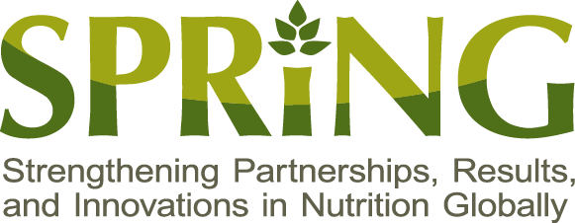
SPRING
JSI Research & Training Institute, Inc.
1616 Fort Myer Drive, 16th Floor
Arlington, VA 22209 USA
Tel: 703-528-7474
Fax: 703-528-7480
Email: info@spring-nutrition.org
Web: www.spring-nutrition.org

